## **Single Page Application vs MultiPage Application**

A Single Page Application is where the server sends what you need with each click, and the browser renders that information without the need to reload the page again. Whereas in the case of a multi-page application every change requests rendering a new page from the server in the browser.

## How Single Page Web Applications Actually Work - DZone

Single page application yani pura page(application) reload nahi hoti msln koi website ka hum about page pr hain aur kisi link pr click kia tu us component ma change ay gi wo puri application reload nahi ho gi.Jbky multipage application ma pura application reload hota ha.

Single Page Application (SPA) and Multi-page Application (MPA) are two different architectural approaches for developing web applications.

Single Page Application (SPA):

- In an SPA, the entire application is loaded initially as a single HTML page, usually accompanied by CSS and JavaScript files.

- The page acts as a container, and subsequent interactions and content updates are handled dynamically within the same page, without requiring a full page reload.

- SPAs often use AJAX and JavaScript frameworks (such as React, Angular, or Vue.js) to facilitate dynamic content loading and rendering.

- Navigation within an SPA typically occurs through client-side routing, where different components or views are dynamically shown or hidden based on user interactions.

- Examples of SPAs include Gmail, Facebook, and Trello.

Multi-page Application (MPA):

- In an MPA, each page of the application is separate and distinct, with its own HTML file, often accompanied by CSS and JavaScript files.

- Navigation in an MPA involves full page reloads, where clicking on a link or submitting a form triggers a server request and loads a new HTML page from the server.

- Each page of an MPA can have its own logic and functionality, and the server is responsible for processing requests and generating the appropriate response.

- Examples of MPAs include traditional websites with multiple interconnected pages, such as news websites or e-commerce platforms.

Key Differences:

1. Loading and Performance: SPAs load all the necessary resources (HTML, CSS, and JavaScript) initially and fetch data dynamically, resulting in faster subsequent interactions. MPAs require full page reloads, which can be slower and less responsive.

2. User Experience: SPAs provide a more seamless and interactive user experience as content updates occur without page refreshes. MPAs can have more abrupt transitions between pages.

3. Development Complexity: SPAs often require more complex client-side development, using JavaScript frameworks and APIs for handling routing, state management, and data retrieval. MPAs rely more on server-side rendering and traditional web development approaches.

4. Search Engine Optimization (SEO): SPAs may require additional techniques (like server-side rendering or pre-rendering) to ensure proper indexing by search engines. MPAs are generally more SEO-friendly as each page can be optimized individually.

The choice between SPA and MPA depends on factors such as project requirements, development resources, desired user experience, and scalability needs. SPAs are commonly used for web applications that require real-time updates, interactivity, and a more app-like experience, while MPAs are suitable for content-rich websites and applications where SEO and traditional page-based navigation are important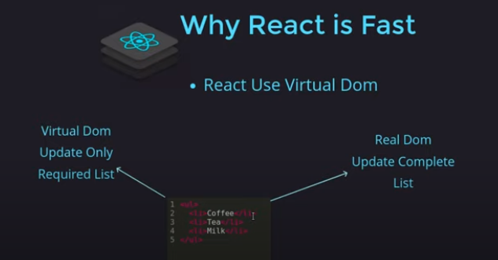

Agr ek list ha [1,2,3,4] tu agr hum normal dekhain tu 4 ki jagha 5 rakhain tu real dom puri list update kry ga jabky virtual dom use krta ha react yani 4 ki jagha 5 rakhny sa dubara new list banna ya baki chezon pr affect na prty sirf required cheze ma hi change ayy gi.

Single page applications work within a single browser session and allow users to jump between parts of the system without requiring the entire page to reload. On the other hand, multi-page applications require a new page to be loaded every time the user interacts with the application.

## **What is meant by Rendering**

<https://www.youtube.com/watch?v=rNVcZklcmqU>

In web development, rendering refers to the process of generating and displaying the final output of a web page or application on the user's browser. It involves taking the code and resources of a web page and transforming them into a visual representation that users can interact with.

There are two main types of rendering in web development: server-side rendering (SSR) and client-side rendering (CSR). Let's explore each of them with examples:

1. Server-Side Rendering (SSR):

Server-side rendering involves generating the HTML, CSS, and JavaScript of a web page on the server and sending the fully rendered page to the client's browser. This approach allows the browser to receive and display the complete page content, making it faster for the user to see and interact with the page.

Example: Suppose you have an e-commerce website with a product listing page. When a user requests this page, the server processes the request, fetches the product data from a database, generates the HTML structure, injects the data into the HTML template, and sends the fully rendered HTML page to the client's browser. The user can immediately see the product listings without waiting for additional JavaScript to execute on the client-side.

2. Client-Side Rendering (CSR):

Client-side rendering involves sending a minimal HTML document to the client's browser, which includes references to JavaScript and CSS files. The browser then downloads these files and executes JavaScript code to dynamically generate the content and render it on the client-side.

Example: Let's consider a single-page application (SPA) built with a JavaScript framework like React or Vue.js. When the user requests the application, the server sends a basic HTML file with links to the required JavaScript and CSS files. The JavaScript code is responsible for fetching data from an API, manipulating the DOM, and rendering the content dynamically on the client's browser.

It's worth mentioning that there can be hybrid approaches that combine both server-side and client-side rendering, such as server-side rendering for the initial page load and then transitioning to client-side rendering for subsequent interactions.

The choice between server-side rendering and client-side rendering depends on factors like the complexity of the application, performance requirements, and search engine optimization (SEO) considerations.

## **Why learn ReactJS?**

# DOM is an object which is created by the browser each time a web page is loaded. It dynamically adds or removes the data at the back end and when any modifications were done, then each time a new DOM is created for the same page. This repeated creation of DOM makes unnecessary memory wastage and reduces the performance of the application. The Document Object Model is a cross-platform and language-independent interface that treats an HTML or XML document as a tree structure wherein each node is an object representing a part of the document. The DOM represents a document with a logical tree.

# yani normale website puri website render bar bar hoti even for a small change but react is for single page application

# 

# React pury web page ko nahi banak r dubara bhejta wo sirf wo changed particular component ko bhejy ga.

# Note: We can use react with cdns means without downloading npm node etc.

# NPM libraries

# npm i react-icons

# npm framer-motion

# Extensions:

# React Developer Tools

* Thunder Client ( Alternative of Postman)
* Auto Rename Tag(Msln humny ek tag banaya <h1> </h1> tu ab agr hum opening tag ko <h1> sa <h2> krain gat tu closing tag automatically </h2> ho jay gay ani hamain manually khud nahi krna pry ga.
* Live Server
* Prettier(Coder formatter)
* Reactjs code snippets (i.e ek file banao aur type kro rfc aur enter tu file ka nam sa functional component ban jay ga aur export line bhi likhi ayy gi).

**Commands**

* npm install sa node_modules ka folder create ho jay ga aur tamam dependencies usmy hon gi jo bhi hamain require hon gi.

Important Points

* Hamain wo tamam tags jinka ending nhi hota msln img,input etc tags unko khud close krna prta ha in react ma

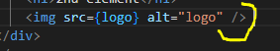

* Humain class ki bajay className likhna prta ha

**Notes**

* Every time the state of an object changes, React re-renders the component to the browser

**Get input box value**

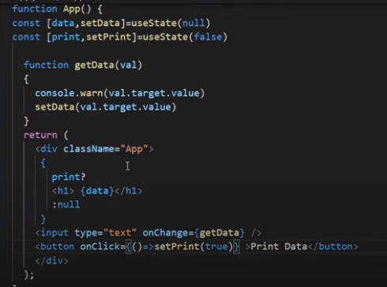

**Conditional Rendering**

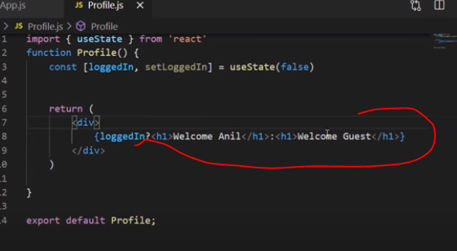

**For multiple if elses**

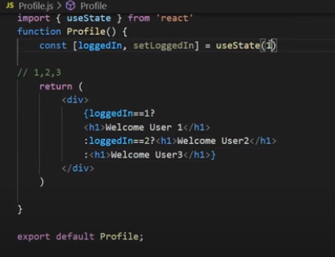

**Difference between npx and npm**

NPM is a package manager used to install, delete, and update Javascript packages on your machine. NPX is a package executer, and it is used to execute javascript packages directly, without installing them. npm ki help sa hum package ko without locally or globally download kiay hum just use kr skty hain.isay hamari storage bhi use nahi ho gi kionky hamain package ko install nahi krna pra.Npm ma hamain package ko locally ya globally apny system ma install krna prta ha msln agr globally install krain taky tamam dusry projects ma use kr sakain koi package tu hum install package ka wqt sath -g lagaty hain i.e npm install -g mongoose ab ye globally install kry ga aur hum kisi bhi project ma use kr sakain ga.Lekin npx ki help sa hum without package ko install kiay use kr skty hain.Msln react project create krny ka liay

npx create-react-app myapplicationname

npm create-react-app myapplicationname

**To run:** npm start

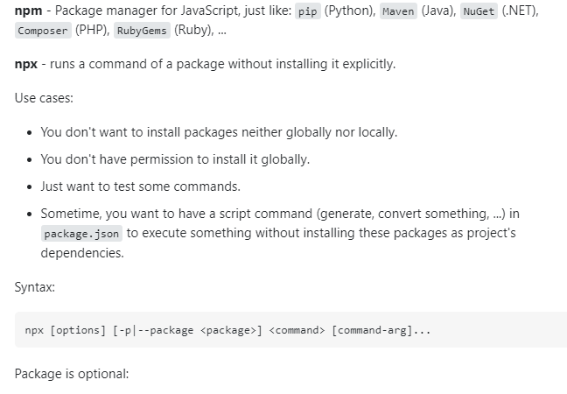

**React Fragments**

Agr hum multiple elements ya components return krwana chahty hain tu hum frgments use krty hain.Yani msln return() isky andr hum ek hi element return krwa skty hain jaisy return(<h1>H</h1>) lekin agr hum return(<h1>H</h1><h2>O</h2>); krna chahty hain tu error ayy ga is liay agr hum multiple values return krwana chahty hon tu hum react framents use krty hain au risky liay hamain return(**<>** <h1>H</h1><h2>O</h2> **</>**) hi krna hota ha sirf.Yani start <> aur end pr </>

Basically fragments ek wrapper provide krta ha taky hum multiple components ya multiple elements etc return krwa sakain.

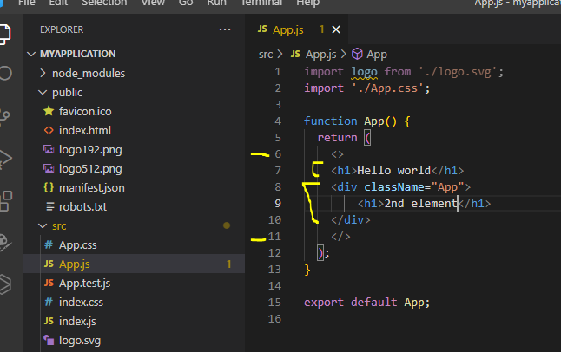

Output



|  |  |
| --- | --- |
| **Method1** | **Method2** |

**Click event and function in ReactJs**

Wrong way to call functions on OnClick Event

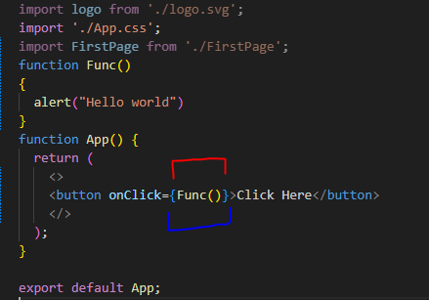

Jb hum aisy call krty hain tu by default jaisy hi application run krain ga without button pr click kiay khud bakhud hi Func() call ho jay ga.

In React.js, when you write `onClick={Func()}` with parentheses after the function name, it means that the function `Func` will be called immediately when the component renders, rather than waiting for the button to be clicked.

This happens because when you use parentheses after a function name, it invokes the function immediately at the point where it is defined. So, in the case of `onClick={Func()}`, the function `Func` will be called as soon as the component is rendered.

To handle the click event properly and call the function only when the button is clicked, you should pass a reference to the function without parentheses. It should be written as `onClick={Func}`. This way, the `Func` function will be called when the button is clicked, as intended.

Corrected code: `<button onClick={Func}>Click Here</button>`

**Pass Props to Functional Component**

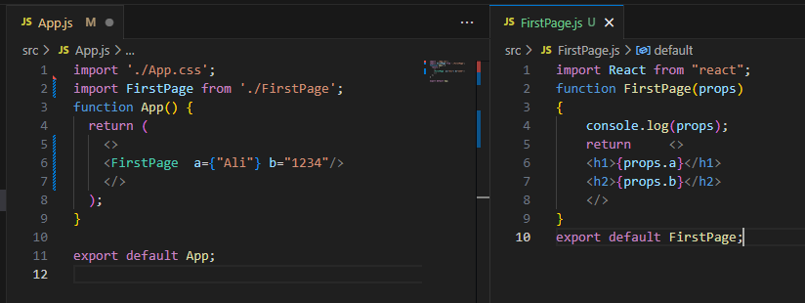

**Class component**

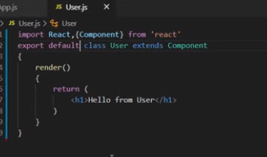ismy render() krna zarori ha

**JSX**

JSX stands for JavaScript XML. JSX allows us to write HTML in React. JSX makes it easier to write and add HTML in React. JSX allows us to write HTML elements in JavaScript and place them in the DOM without any createElement()  and/or appendChild() methods.Jsx ki help sa hum javascript ka andr html likh paty hain.

JSX converts HTML tags into react elements.

**JSX allows us to write HTML directly within the JavaScript code.**

**JSX is an extension of the JavaScript language based on ES6, and is translated into regular JavaScript at runtime.**

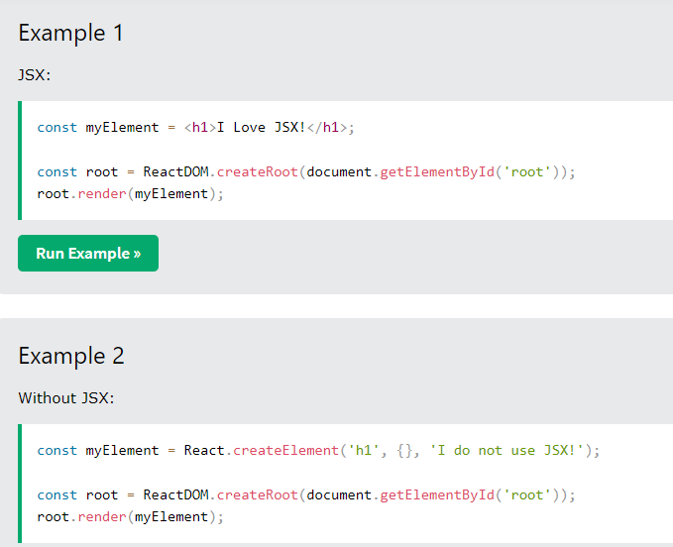

Yani hum javascript aur html code ek sath hi likh skty hain

**DOM Vs Virtual DOM**

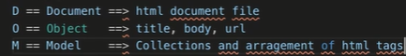

Document yani hamari html ki msln jo file ha wo aur object yani us file ka andr jo tags hain jaisy img,input,body,head,title,anchor tags etc jo hain wo sb.Hum yani apny document(html file) ka andr ka Objects(msln tags) etc manipulate kr skty hain.Msln hum console.log(document) krain tu puri file ka code sara a jay ga hamary samny aura gr hum is document(file) ka andr koi object access krna chahty hain tu jaisy console.log(document.title) likhty hain tu is file ka andr ka title tag print ho jay ga aur document.title.value sa is title tag ka andr ka content hum get kr skty hain.

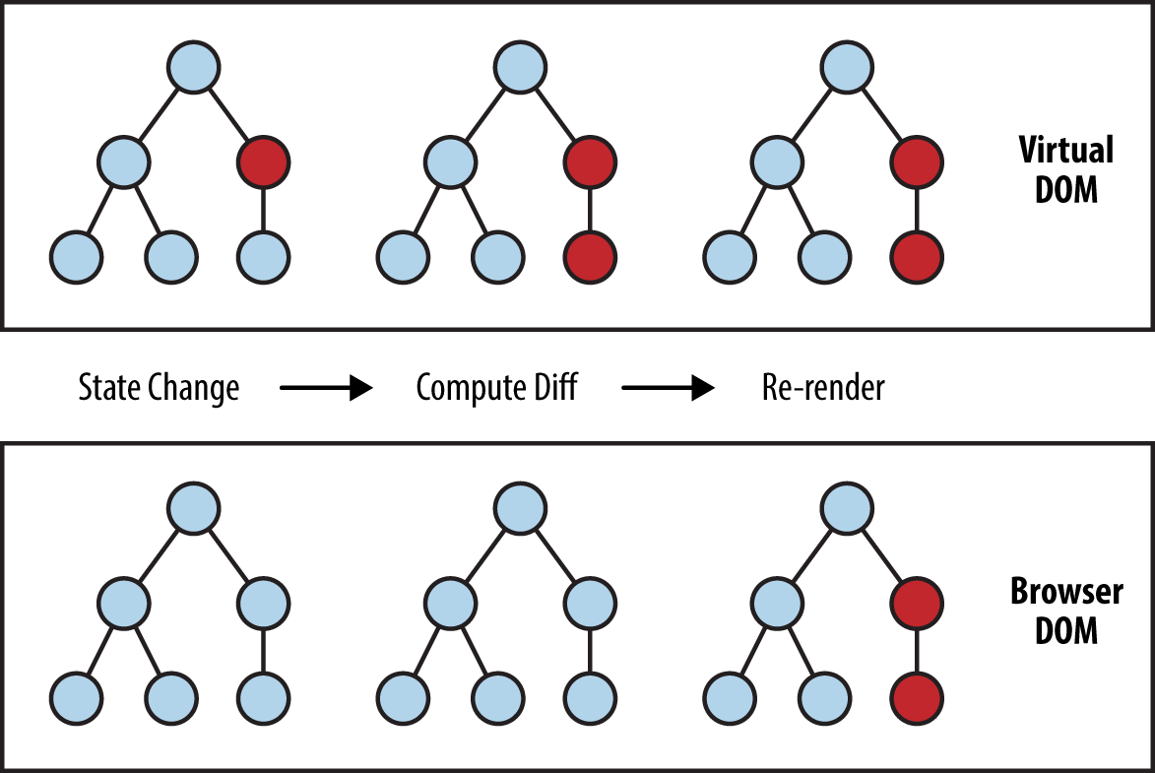

Msln virtual dom ka ek component ma change hoi ,abhi original dom ma change nahi ho gi.Ab virtual dom ka dusry component ma bhi msln change hoi lekin original dom same waisy hi.Ab jb mazed kisi virtual dom ka node ma change nhi require aur jb rerendering hoti ha tu automatically Original browser DOM ma changes reflect ho jati hain.Is trha benefit ye ha ka hr change ka liay page refresh nahi hona prta aur yanii pury dom ko sirf ek cheze ka liay bar bar update nahi hona prta.Wrna by default ye tha ka hum jb original dom ka kisi ek bhi node ma change krty thy yani msln dom ka andr kisi <h1> tag node ka innder text change kia tu pura DOM refresh ho ga aur ye costly operation ha agr ziada nodes at a time update kiay jaien tu pura dom bar bar update ho raha ho ga hr change ko accommodate karny ka liay.Iski bajay hum virtual dom ma changes krty hain aur rerendering ka wqt original dom ma changes reflect ho jati hain.

<https://www.geeksforgeeks.org/reactjs-virtual-dom/>

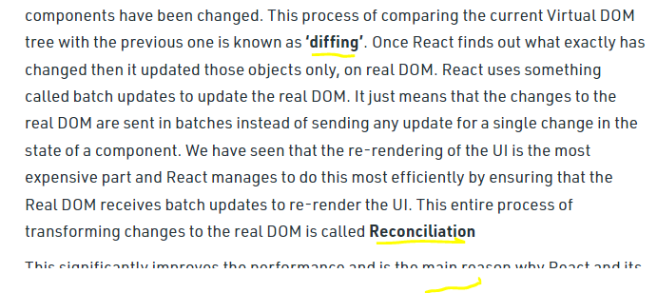

The virtual DOM works fast as it only changes individual DOM elements instead of reloading complete DOM every time.

**Babel**

Babel is a JavaScript Compiler. Babel is a JavaScript transpiler, meaning it converts a newer version of ECMAScript, such as ES9, to a standard version (ES5).Babel is a toolchain that is mainly used to convert ECMAScript 2015+ code into a backward compatible version of JavaScript in current and older browsers or environments.Babel can convert JSX syntax! Babel is used to convert the jsx to js.

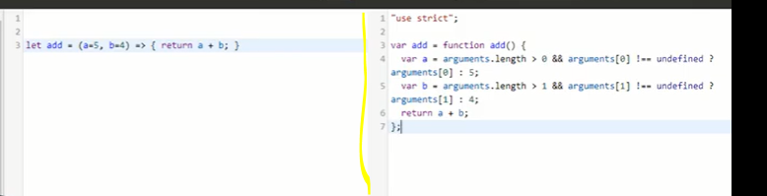

Yani ecmascript ya latest jo bhi syntax etc wo hr browser support nhi krta jaisy maybe arrow function kisi browser ma support na krta ho tu wahan tu ye function work ni kry ga is liay babel ko use kia jata ha kionky ye automatically convert kr deta ha un tamam syntaxes code ko pure javascript ka code ma taky tamam browsers ma code work kr sky.is trha hum latest syntaxes hi use kr skty hain bagair soxhy ka ye syntax kisi browser pr support kry gay a nahi kionky babel hamary latest syntax ko convert kr da ga javascript pure code ma.

**Difference between package-lock.json and package.json?**

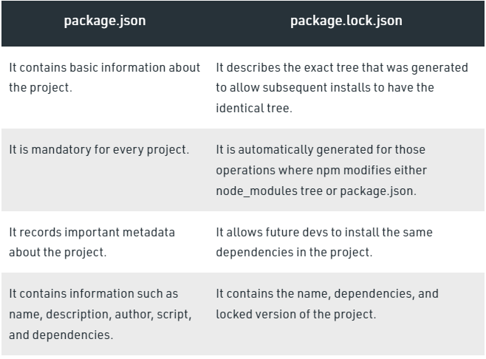

<https://dillionmegida.com/p/package-vs-package-lock-json/>

Jo bhi hum package download use krain ga uska version nae aur uska nam package.json file ma a jay ga lekin package.lock json file ma us package ki details hon gi ziada msln us package ki subdependencies ya versions etc

**Event Handling in Class Component**

Note:class component ma sbsy pehly by default constructor call hota ha even render() ma html javascript etc load hony yani render() ka call hony sa pehly hi constructor call ho jata ha.Constructor ma ham states etc define krty hain lekin apis kabhi ismy call nhi krty.

Agr hum constructor likh rahy hain class component ma tu hamain super() lazmi likhna ho ga

How to make custom functions in class component?

Method1:

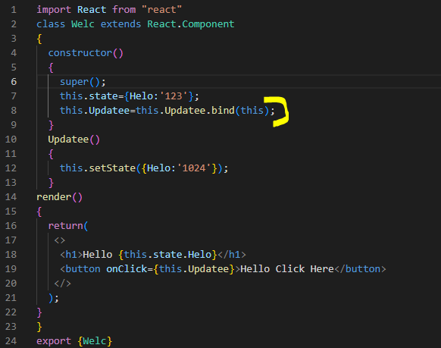

Ismy hamain bind krna prta ha function ko

Method2 Easy Method: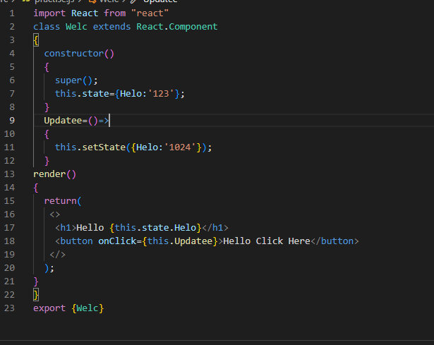

Yani functional expression use kr lain agr hamain tu hamain function ko bind krny ki zaror nahi ye automatically perform ho jay ga.

**Method3**

Ismy function call krty howay hum bind kr lety hain

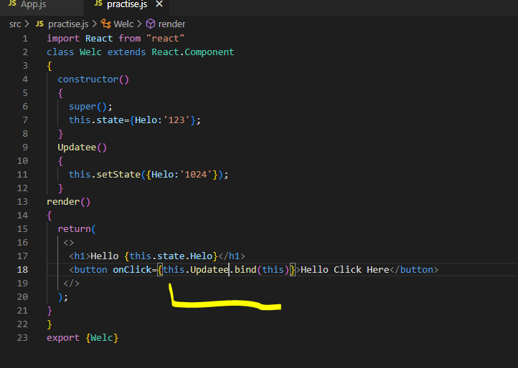

Agr hum khali onClick={this.Update()} likhain ga tu usko lgy ga ka ye this onClick() ko point kr raha ha current object kion.Is liay hum bind krky bataty hain ka this.Update.bind(this) yani class ka jo this ha hum wo argument ma dety hain ka class ka sath binding ho aur class ka mention method call ho

**Event Handling in Functional component**

Functional component ka andr this nahi hota.this object sirf class component ka andr hota ha.

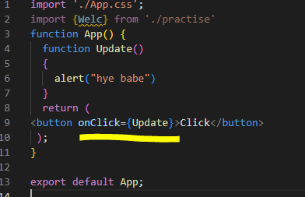

**What is life cycle method**

Each component in React has a lifecycle which you can monitor and manipulate during its three main phases.

The three phases are: **Mounting**, **Updating**, and **Unmounting**.

Hum Apis componentdidmount ma call krty hain

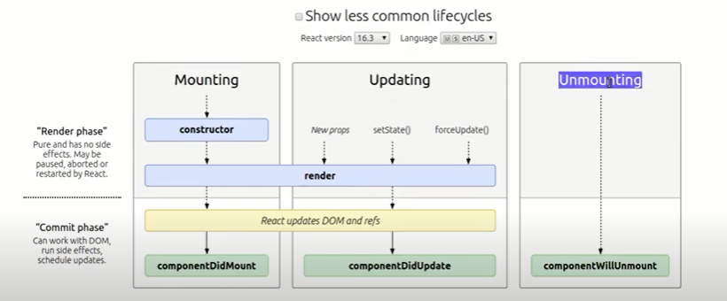

**Mounting**

The main job of React is to figure out how to modify the DOM to match what the components want to be rendered on the screen. React does so by "mounting" (adding nodes to the DOM), "unmounting" (removing them from the DOM), and "updating" (making changes to nodes already in the DOM).Yani jo sary elements html ha wo sary jb load hoty hain isko moutning kehty hain.Jb sary html elements dom yani load ho jata ha tb componentDidMount() call hota ha.Hum componentDidMount() ma apis call krtt hain yani taky jb render() call ho kionky html sara dom render() ka andr hota ha tu jab yani rendering perform ho ja tb apis call hon.

### **componentDidMount()**

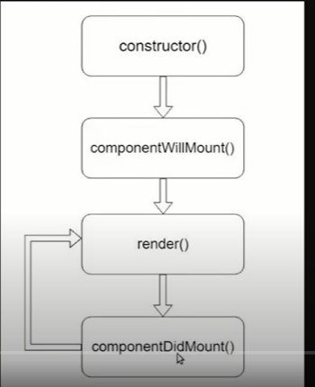

Figure 1sbsy pehly constructor call hota ha usky bad componentWillMount() usky bad render call hota ha jo compulsory method ha class ka .Isky bad componentDidMount() call hota ha.Agr koi bhi state etc ma change update ho tu render() dubara sa call hota ha.Hum apis etc componentDidMount() ma call krty hain taky jb sb ready ho tb api call ho.

<https://programmingwithmosh.com/javascript/react-lifecycle-methods/>

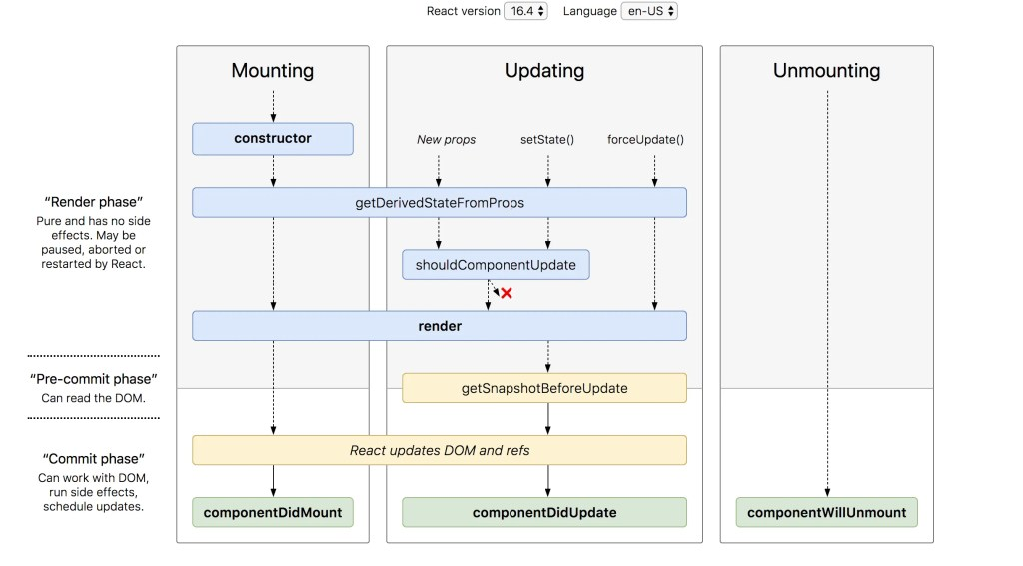

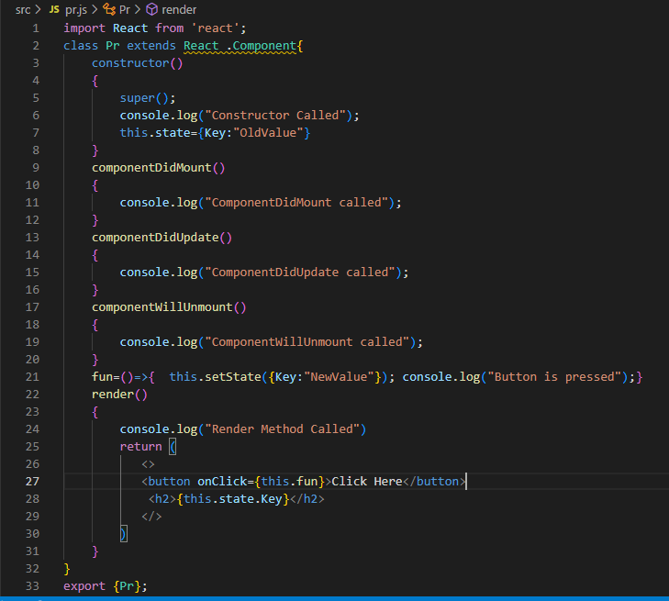

Output

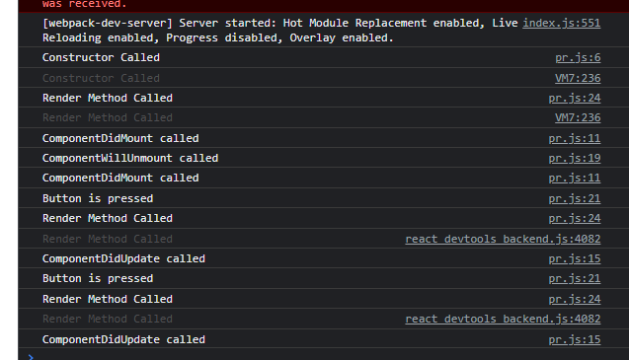

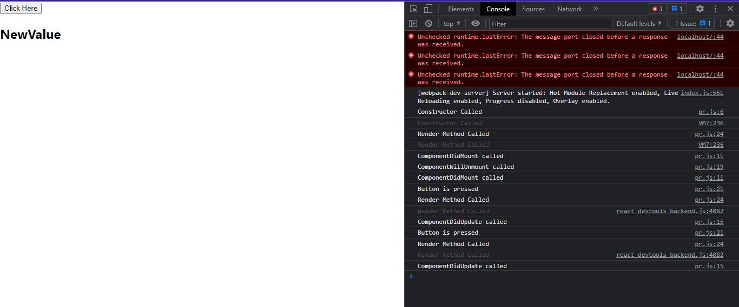

componentDidMount()is called as soon as the component is mounted and ready. This is a good place to initiate API calls, if you need to load data from a remote endpoint

ComponentDidUpdate() hamesha tb call hota ha b hum koi state etc ma change krty hain.Hum isky andr hamesha conditional statement zaror use krty hain wrna ye infitinitve time looping ma chala jay ga.Kionky msln hum ismy ek state update krwaty hain bagair condition ka tu jb ye call ho ga ismy state update ho gi aur dubara ye call ho ga phr iski body execute ho gi state update ho gi aur dubra ye call ho ga.is tarha ye process continuously chalta rahy ga

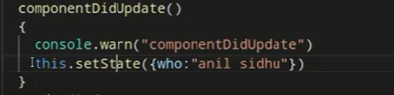

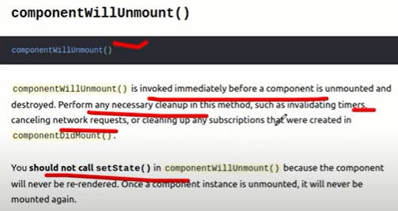

**shouldComponentUpdate life cycle method**

The `shouldComponentUpdate()` lifecycle method in React should be used when you want to optimize the rendering performance of your components. This method allows you to control whether a component should re-render or not, based on certain conditions or changes in props or state. By implementing `shouldComponentUpdate()`, you can prevent unnecessary re-renders and improve the overall performance of your React application.

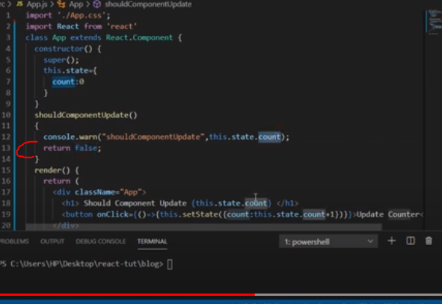by default ye aisy hota ha pr hamain return true krna hota ha otherwise ye state ma change nahi hony da ga.

Here are some scenarios where you might consider using the `shouldComponentUpdate()` method:

1. Performance Optimization: If a component's props or state are frequently changing, but the component doesn't actually need to re-render in response to every change, you can implement `shouldComponentUpdate()` to perform a shallow comparison of the incoming props and state with the current ones. If the comparison shows that there are no significant changes, you can return `false` from `shouldComponentUpdate()` to prevent the re-rendering of the component.

2. Avoiding Expensive Operations: Sometimes, a component's re-rendering might trigger expensive operations such as API calls, heavy computations, or DOM manipulations. By implementing `shouldComponentUpdate()`, you can check if the specific props or state that trigger these operations have changed. If they haven't changed, you can return `false` to skip the re-render and avoid the unnecessary expensive operations.

3. Fine-grained Control: In certain cases, you might want to optimize the rendering of a specific component by preventing re-renders in certain scenarios. By customizing the logic inside `shouldComponentUpdate()`, you can have more control over when a component should re-render, allowing you to optimize rendering based on your specific requirements.

It's important to note that `shouldComponentUpdate()` is an optional lifecycle method, and by default, React components will re-render whenever there is a change in their props or state. You should use `shouldComponentUpdate()` judiciously and carefully test its impact on your application's performance.

Additionally, it's worth mentioning that in React functional components, you can achieve similar functionality to `shouldComponentUpdate()` using the `React.memo()` higher-order component or the `useMemo()` hook, which can help optimize the rendering of functional components by memoizing their results.

# React Hooks

Hooks allow function components to have access to state and other React features. Because of this, class components are generally no longer needed. You must import Hooks from react

Although Hooks generally replace class components, there are no plans to remove classes from React.

## **Hook Rules**

There are 3 rules for hooks:

* Hooks can only be called inside React function components.
* Hooks can only be called at the top level of a component.
* Hooks cannot be conditional

**Note:** Hooks will not work in React class components.

## **Custom Hooks**

If you have stateful logic that needs to be reused in several components, you can build your own custom Hooks.

<https://www.w3schools.com/react/react_hooks.asp>

Pehly class components ziada use hoty thy lkin kionky functional components easy to use thy lekin unmy class component ka muukably ma kab features thy jaisy states life cycle methods etc hum sirf class components ka sath use kr skty thy is liay hooks intorduce kiay gay aur ab hum jaisy state functional component ma bhi use kr skty hain isi trha life cycle methods class components ma thy usi trha alternatively usememo,useeffect etc methods functional component ma bhi hoty hain.

***Routing***

Install React router: npm install react-router-dom

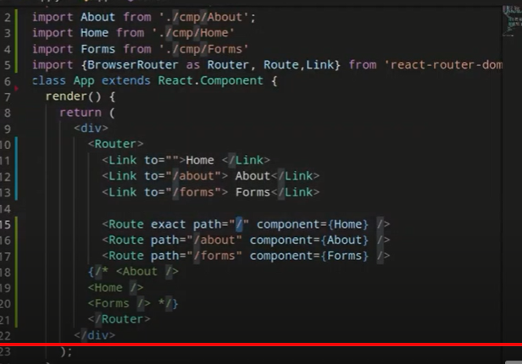

By default home wala sb pages routes ka andr show ho ga lekin agr hum chahty hain ka jo root ha uska mentioned component hi usmy show ho tu hum router tag ka andr exact da dety hain.

**Conditional Rendering**

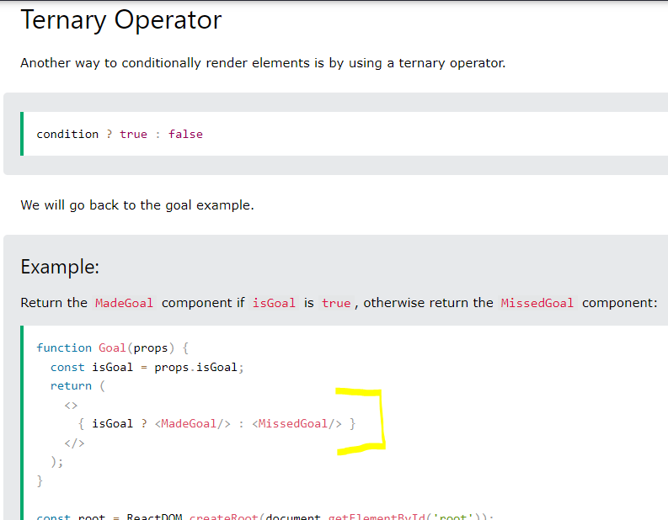

This is equal to if else.

**Pass Function as Props**

|  |  |
| --- | --- |
|  |  |

**Render life cycle method**

Jb bhi html ma kuch bhi change hota ha tu render() dubara sa call hota ha yani re-rendering.msln koi props ya states etc update hoty hain tu re-rendering yani render() dubara sa call hota ha.render() call hota ha jb screen load ho gi(jb component load hota ha),jb state/props(arguments) update hon ga tb.

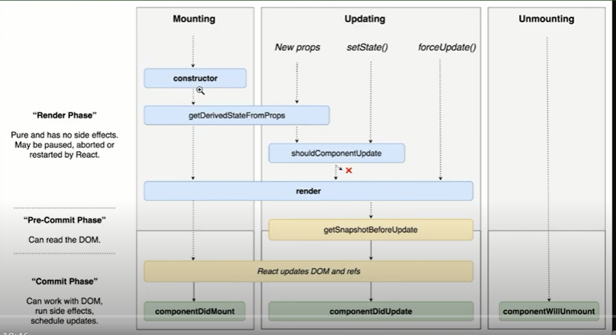

**ComponentDidUpdate**

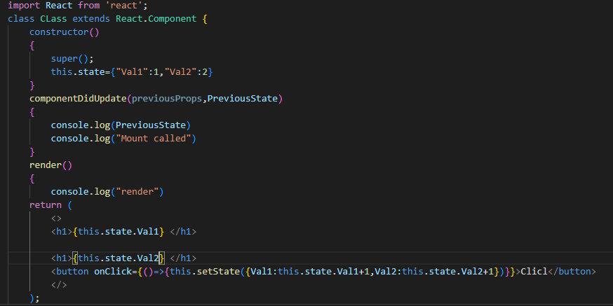

Jb bhi koi state ya props update hon ga tu componentDidUpdate() call hota ha aur isky andr arguments hoty hain previous props and previous state yani msln previous state object ka andr previous value recent wali store hoti ha jo update hoi.Msln humny button pr press kia tu Val1=2,Val2=3 lekin previousState={val1=1,Val2=2} ho ga.ComponentDidUpdate() ka andr kabhi bhi without conditional statements ka kuch bhi update msln states ki value ko update nahi krty wrna error ayy ga ka max limit excceded kionky

Note: render() ka andr hamain kabhi bhi state update nahi krwani chahiay

**shouldComponentUpdate life cycle method**

yani hum chahty hain ka agr render() na call ho ya sirf is particular value pr msln a=5 state howa update tu render() na call ho tu hum ye method use krty hain jismy return false/true decide krta ha ka render() call krna ha ya nahi.

**componentWillUnmount life cycle method**

Basically jb hum koi element msln hide show krty hain tu hum wo element ko dom sa complete delete krty hain tb ye unmount call hota ha.

**shouldComponentUpdate() componentdidupdate() sa pehly call hota hai**

**Agr shouldComponentUpdate() true return kry ga tu componentdidupdate() call nahi ho ga vicevera.**

**Note:ye outer brackets ye jsx ki hain aur andr wali object liay**



**Hooks**

With Hooks we can use class component features in functional components such as state,life cycle,pure component etc

**useEffect()**

The useEffect Hook is called every time the component renders. It works similarly to componentDidMount and componentDidUpdate in React class components

useEffect() by default each time jb rendering hoti ha tu call hota ha aur ye ek function as argument apny andr expect krta ha aur dusra argument ek dependency jo ka optional hoti ha.Yani by default jb bhi render() call hota ha har render() ka call hony ka bad useEffect() call hota ha lekin agr hum chahty hain ka useEffect() sirf first time hi render() ka call hony ka wqt call ho yani usky bad nahi tu hum empty array as dependency dusry argument ma pass kr dety hain.Agr hum chahty hain ka kisi msln specific state ki value update hony pr hi call ho useEffect() tu hum us state ka nam array ma bhej dety hain as second argument in useEffect().

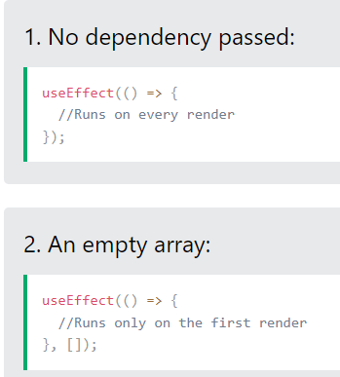

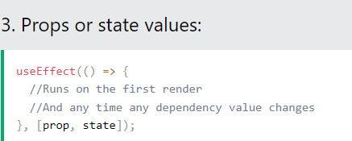

Hum multiple times useEffect() ko call kr skty hain yani hum define kr skty hain useEffect() different scenarios ka liay

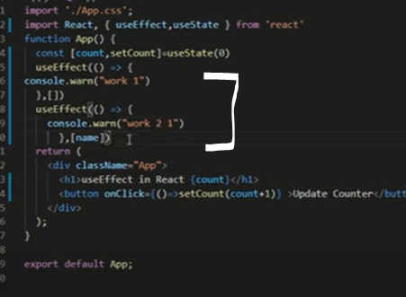

**Css inline styling**

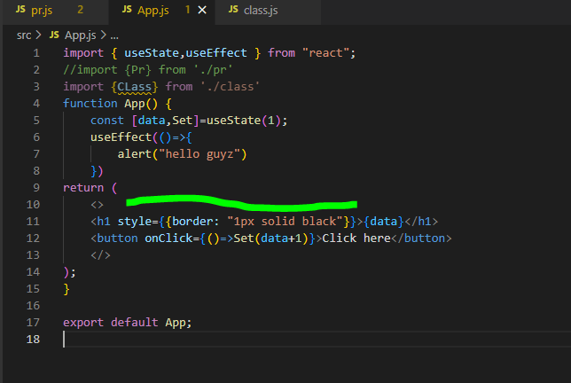

**Bootstrap**

React ka andr bootstrap ki bhi library ha yani humain bootstrap ka module package download krna ho ga react yani npm krky aur phr us module ko import krna ho ga index.html aur components sary react ki official website pr pry hain.

Why map() instead of for loop?

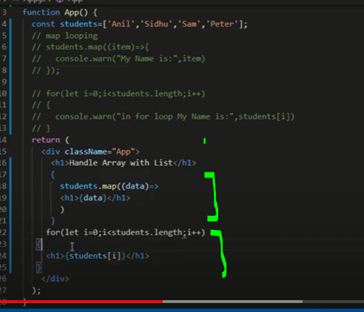

Hum return ka andr map() use kr skty hain lekin for loop nahi likh skty return() ka andr wrna error ayy ga.Hum return sa auper likh skty hain bahir for() loop lekin return() ka andr for loop nahi likh skty lekin map() hum kahien bhi use kr skty hain return ka andr aur bahir bhi.Msln

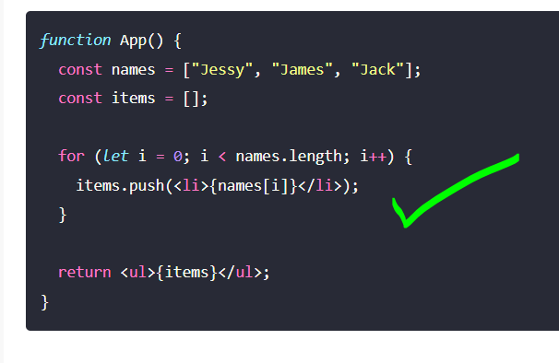

Lekin ye for loop hum return ka andr nahi likh skty.

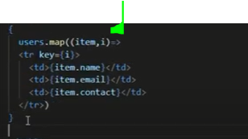

Map() ko use krty howay behtr ye ha ka hum 2 arguments lain first one jismy value ayy aur 2nd argument ma indexing ka liay .Ye achi approach ha wrna agr hum 2nd argument nahi lety tu dom bhi nhi thek sa bnta aur unique ids elements ka liay hum use krty hain indexings.

**Fragments**

Ye multiple elements ko wrapper provide krta ha taky hum unko return krwa sakain.

**Lifting State Up or Send Data Child to Parent Component**

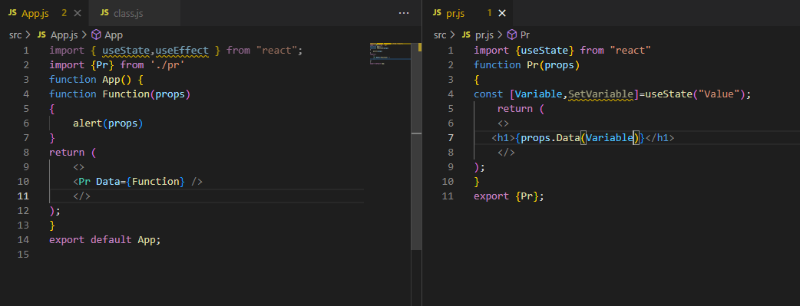

**Send Data from Parent to Child Component**

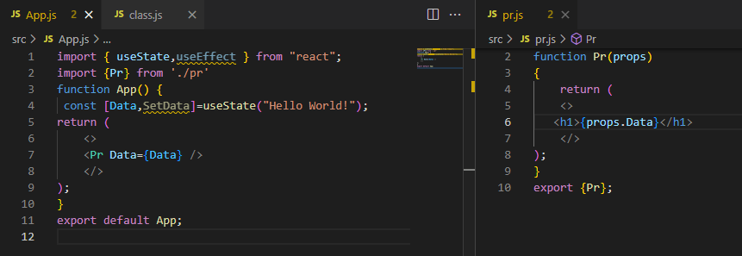

# Pure Components in React

**Pure Components** in React are the components which do not re-renders when the value of state and props has been updated with the same values. If the value of the previous state or props and the new state or props is the same, the component is not re-rendered. Pure Components restricts the re-rendering ensuring the higher performance of the Component.Pure components hamary component ki unnecessary re-rendering ko rokta ha.Isky alternative ma useMemo hook functional component ma hota ha.

**Features of React Pure Components**

* Prevents re-rendering of Component if props or state is the same
* Takes care of “shouldComponentUpdate” implicitly
* State and Props are Shallow Compared
* Pure Components are more performant in certain cases

Class ma render() tb call hota ha jb msln koi state update ho ya props etc update hon lekin msln humny ek button lagaya ka agr ispr click krain tu state ma 1 add ho tu yani state update ho gi tu render() bar bar call ho ga lekin agr msln pehly state ki value=5 thi aur update hony ka bad phr sa 5 ha tu render() call ho ga aur bar bar render() call hony ki waja sa websie performance effect ho gi is liay hum Pure components use krty hain yani agr value previous aur current same ha tu dubara sa render() call na ho yani rerendering na ho.

Similar to Pure Functions in JavaScript, a React componentis considered a Pure Componentif it renders the same output for the same state and props value. React provides the PureComponent base class for these class components. Class components that extend the React.PureComponent class are treated as pure components.

# In the case of Pure Components, the React components do not re-render blindly without considering the updated values of React “props” and “state”. If updated values are the same as previous values, render is not triggered. Pure Components restricts Re-Rendering

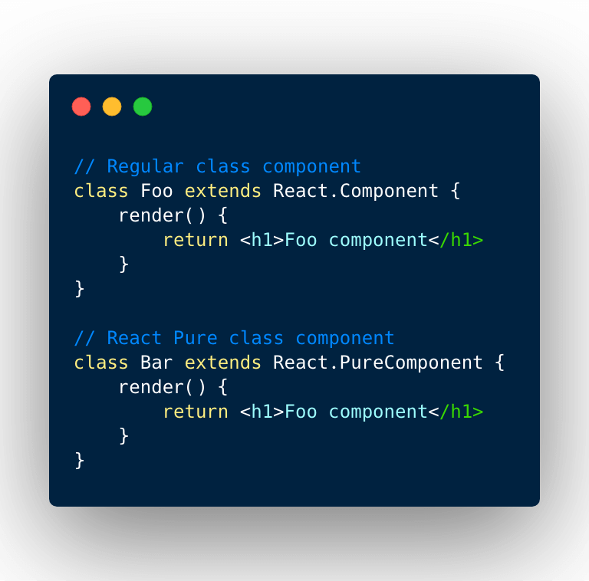

UseMemo

Hamri states update nah bhi hoti ya msln a=1 tha aur kuch hony ka bad ho kr phr sa update ho kr a=1 howay tu kuch functions unwantely call hoty hain aur speed performance affect hoti ha is liay hum useMemo() use krty hain.

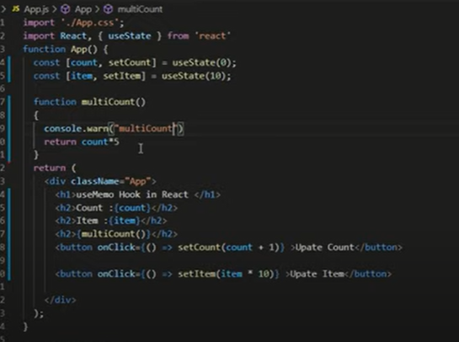

Msln 2 states hain aur sirf ek update ho rahi ha dusri nahi lekin still tamam functions dubara render() ho rahy hain aur performance speed affect ho rahi ha.is liay hum useMemo() use krty hain jo ka hamary code ki performance ko behtr krta ha.

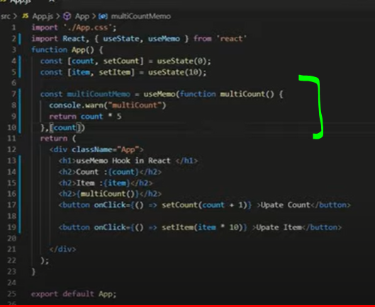

Humny usememo lagaya aur usmy dependency bhi laga di ka sirf count state ka update hony pr chaly ye function otherwise ye function kisi bhi state props etc ka change hony pr na chaly.



# React useRef Hook

Ref directly dom ko manipulate krta ha is liay react.js avoid krti ha ka ziada iska use na kia jay. It can be used to access a DOM element directly.Hum jaisy input tag ki values state sa get krty hain ya kisi element ko hide show krwany ka liay states use krty hain pr hum ye sab useRef sa directly kr skty hain. Ref class component ma hota ha aur useRef functional component ma.jaisy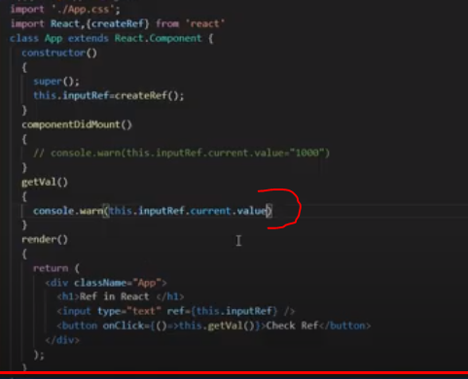

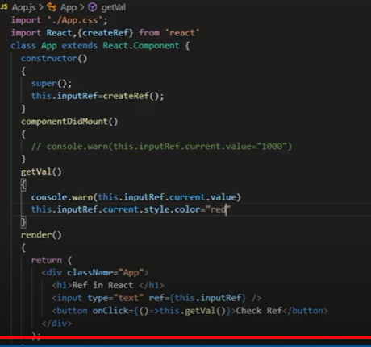

Yani hum dom ko manipulate krny ka liay msln hum is input box ki styling kuch bhi kr skty is ki value update delete stylig etc kr skty hain because of ref hook.

Class ma Ref use hota ha aur function ma useRef use hota ha. 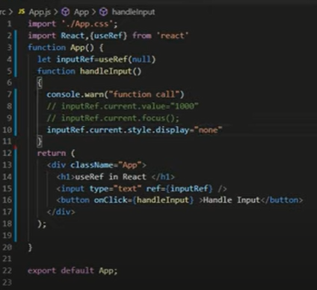

DOM ko directly manipulate krny ka liay hum useRef use krty hain

**ForwardRef Hook**

https://blog.logrocket.com/use-forwardref-react/

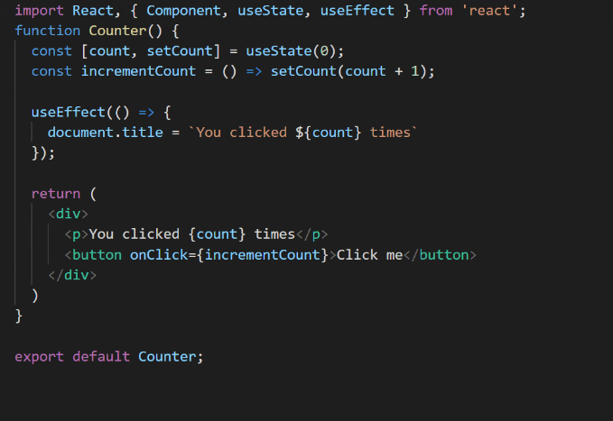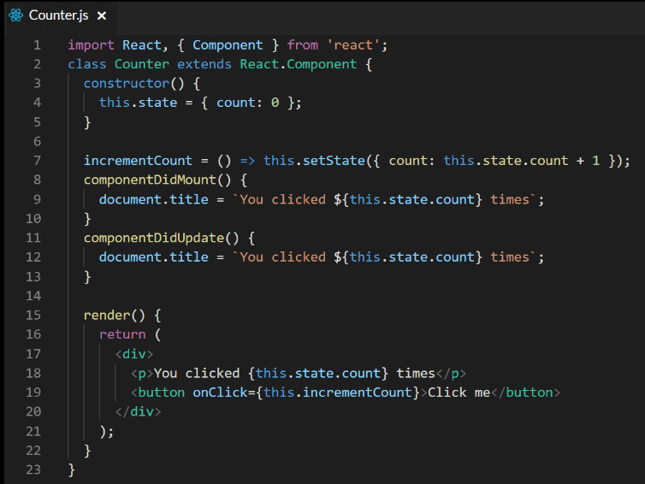

**usecontext hook in react**

React Context is a way to manage state globally.

It can be used together with the useState Hook to share state between deeply nested components more easily than with useState alone.

<https://medium.com/technofunnel/usecontext-in-react-hooks-aa9a60b8a461>

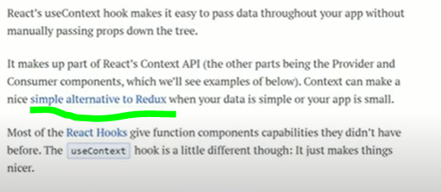

Hum GrandFather sa agr grandson ko koi data bhejna chahty hain tui ska ek tareka ha prop drilling yani GrandFather sa hum parent ko prop ma data bhejain ga aur parent wo prop agy apny son ko yani is trha grandson tk data pohanxy ga isko prop drilling kehty hain.

Dusra method using redux ha.

Tesra method using useContext hook ha.

Example:

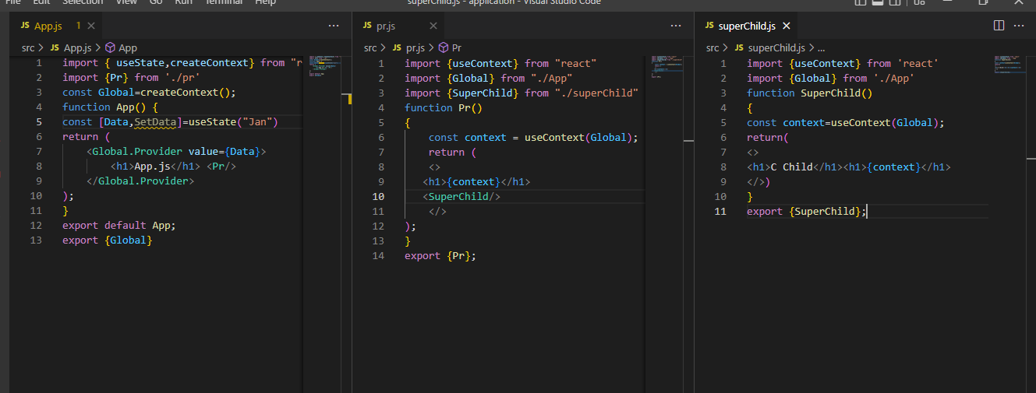

Output:

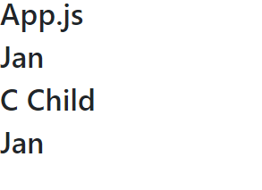

Example2

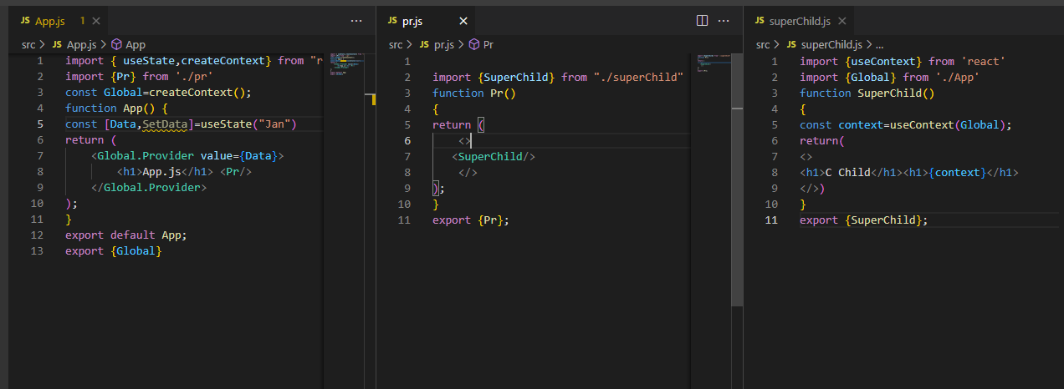

Output



Example3: Dealing with multiple values

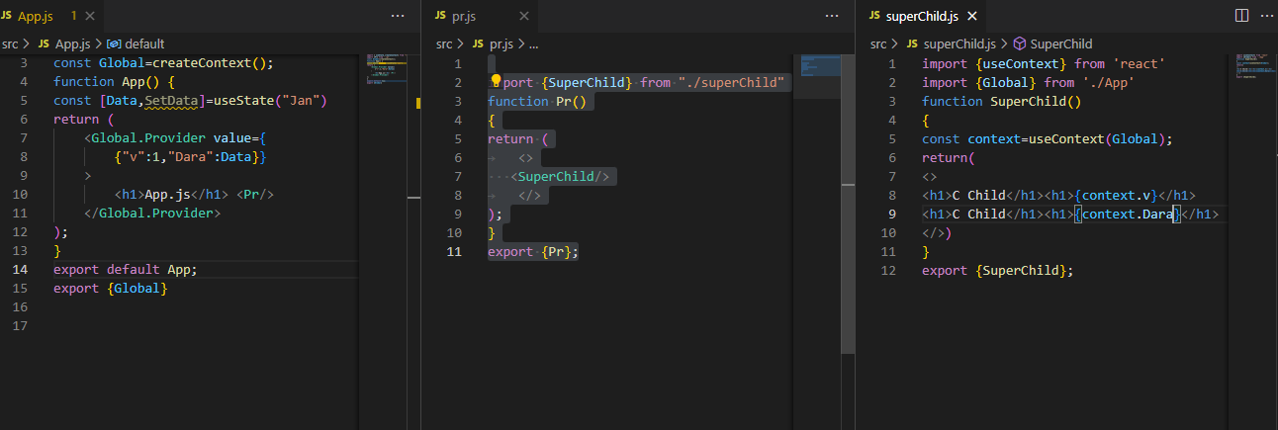

Output:

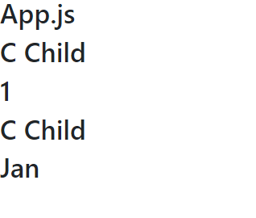

Context Api ka andr 3 chezain hoti hain context,provider aur consumer.lekin consumer ki bajay ab useContext ha. line3 ma sbsy pehly humny ek context bna lia jismy power ha consumer Aur provider ki.isky bad hamain apny jo bhi components banany hain humain wo apny context provider ka andr rakhny hain yani ye ek trha ka wrap-up ha. Ab kionky ye ek itselft component ha tu humain kisi aur file ma use ka liay isko import krna pry ga jisky liay hamain pehly isko export krna pry ga context ko.

Note:Jis file ma hum context create krain ga us file ka jitney bhi sub-childrens hon ga unsbmy available ho ga context ka andr jo values humny di hoi state ya props etc.

**useReducer()**

The useReducer() hook in React lets you separate the state management from the rendering logic of the component.

const [state, dispatch] = useReducer(reducer, initialState) accepts 2 argument: the reducer function and the initial state. Also, the reducer returns an array of 2 items: the current state and the dispatch function.

When you'd like to update the state, simply call dispatch(action) with the appropriate action object. The action object is then forwarded to the reducer() function that updates the state. If the state has been updated by the reducer, then the component re-renders, and [state, ...] = useReducer(...) hook returns the new state value.

useReducer() fits great with relatively complex state update (requiring at least 2-3 update actions). For simple state management, simply use useState()

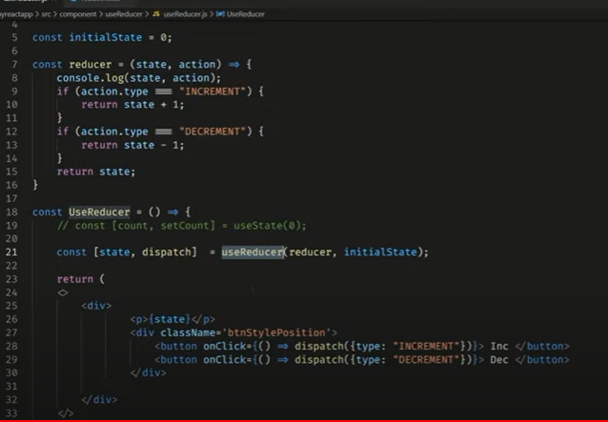

Yani depending on specific action hum us action ka mutabik state value update kr skty msln agr hum chahty ka action increment tu state ma add ho aura gr state action decrement ha tu state ma decrement ho.Otherwise hamain aledha yani state update wali lines different likhni prta yani add ka liay separate llikhty ka setSetate(state+1) aur setState(state-1) lekin ab hamain yani ek wrapup reducer ka andr huny likh dia ka agr any wala action ye ho tu ye ho otherwise ye ho.

# Controlled vs. uncontrolled components in React

React ka andr jab hum input fields etc ko state ka through values get krty unko manage krny ka liay states ko use krty tu usko kehty hain controlled components.Lekin agr hum yehi koi input field pr id ya class laga kr getElementByID etc ka through directly DOM ko target krty values get krty hain tu unko uncontrolled components kehty hain jaisy hum useRef hook ka through kisi input field ki value get krty hain tu ye controlled component ho ga jbky who agr hum kisi input field ki value state ma rakhwa rahy (i.e onchange laga dia ka jaisy input field ki value change ho tu us state ma update store hoti rahy) tu ye Controlled component.

The form is one of the most-used HTML elements in web development. Since the introduction of React, the way forms have been handled has changed in many ways.

In React, there are two ways to handle form data in our components. The first way is by using the state within the component to handle the form data. This is called a controlled component. The second way is to let the DOM handle the form data by itself in the component. This is known as an uncontrolled component.

<https://blog.logrocket.com/controlled-vs-uncontrolled-components-in-react/>

* Uncontrolled component mtlb wo components jo directly dom ka through manipulate handle hon msln hum koi input field lain aur uski id ya class ya tag name ka through dom ka through javascript ya jquery sa uski id class tagname etc sa value get krain us field ki.Yani bs state ka through kuch bhi handle na ho isky elawa koi bhi method msln hum use ref sa get kr lain input field ki values ya id tag name etc ka zriay get kr lain values fields ki lekin state na use ho bs.
* controlled component yani mtlb input fields jo handle hon using react state.
* 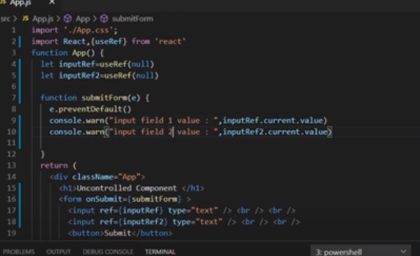i.e ye imge ma uncontrolled component example ha.

**High Order Component**

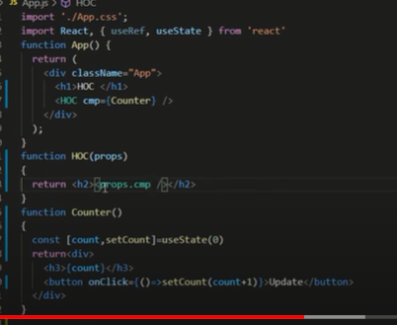

Aisy component(functions) jo as argument(props) kisi dusry function(component) ko lain aur return bhi ek function(component) krain

**React Router v6**

Yani different pages hoty hain different links ka liay msln https:localhost:5/ ispr ek page khuly ga home wala aur https:localhost:5/about pr about us page khuly ga is trha yani hr link ka liay hum page banaty ab uspage yani wo link browser ma dalain tu wohi page open show ho isky liay hum routing set krty hain.

npm install react-router-dom

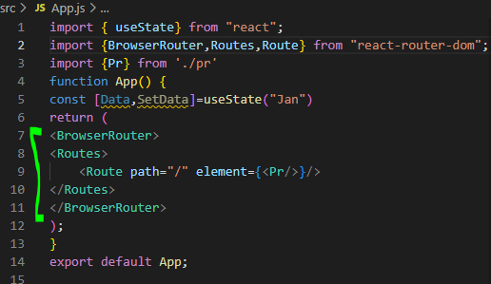

BrowserRouter ek wrapup provide like ek container provide krta ha jisky andr hum routes set krty hain.Agr sirf ek route set krna ho tu route akela likha ja skta lekin routes yani different paths ka liay different route deny hoty hain is liay in different route ko routes ka wrapUp ma dalty hain aur Routes ko BrowserRouter ka andr.

Hm links bhi bana skty hain lekin usky to ma same wohi path dena ho ga taky is link pr jb click ho tu route ka andr element wo load ho

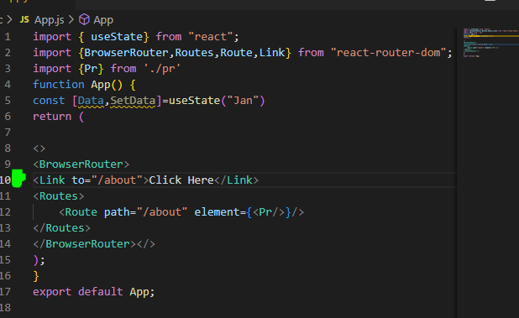

Why we are using Link tag instead of anchor tag? Because link tag sa page refresh nahi ho ga jbky ancor tag sa page refresh hota ha beshk target ma blank etc kuch bhi ho page refresh hota ha yani load new hota ha. The href attribute would trigger a page refresh which would reset the application states. However the link and navlink of react-router doesn't trigger a page refresh. Since React is used to create single page applications most of the time make sure you choose Link or Navlink when working with routing

**404 Page**

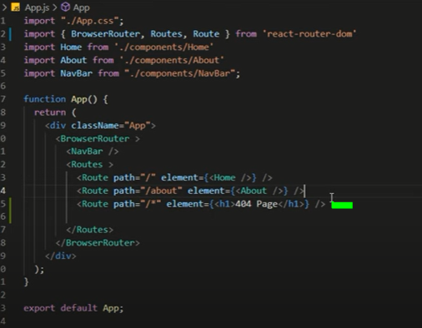

Yani humny kaha ka agr auper diay gay paths ma sa koi bhi path match na kry aur koi unknown new path pr user redirect krny ki koshish kr raha ha jo hamari website ma nahi ha tu 404 Page not found error ki bajay hamara custom page hum dikha skty hain.

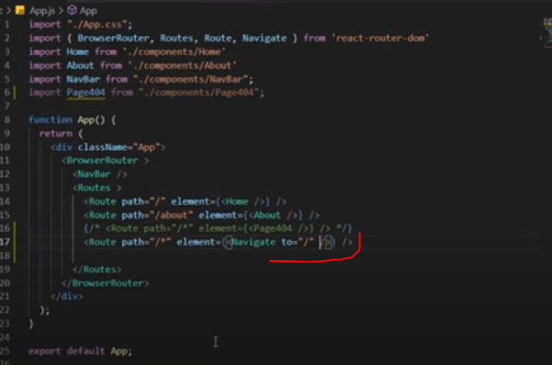Agr hum chhaty hain ka agr koi path jo nhi exist wo enter howa tu ye kisi jaisy home ka page pr redirect ho jay ya about us ka tu hum navigate ma likhty hain.

**Dynamic Routing with params**

Why we use Dynamic routing with parameters?

Msln hamari website ma list ha jaisy



Ab hum agr ye 10nam likhy tu 10 links tu nahi na banaien ga ka

<Route path=”Usa” element={}/>

<Route path=”Turkey” element={}/>

<Route path=”Iran” element={}/>

<Route path=”SuadiArab” element={}/>

<Route path=”Pakistan” element={}/>

Kionky hum chahty ka jo bhi yani jispr link item pr click ho tu us particular item ka data show ho jay.Jais e-commerce webste ma different products ab jis particular product pr click kro tu usi page ya next page ma usi ki sirf details show hoti hain tu ab aisa nahi hota ka hum tamam products ka lia alag alag routes banaien jinky paths ma un products ka nam likha ho.Iski bajay hum sirf ek route banaty lekin usmy yani dynamic routing krty hain kionky jo particular ho ga wo as a parameter jay ga aur database ma search ho ga aur sirf usi ka data show krwana ha hamain.msln

<Route path=”/about/:Name” element={} />

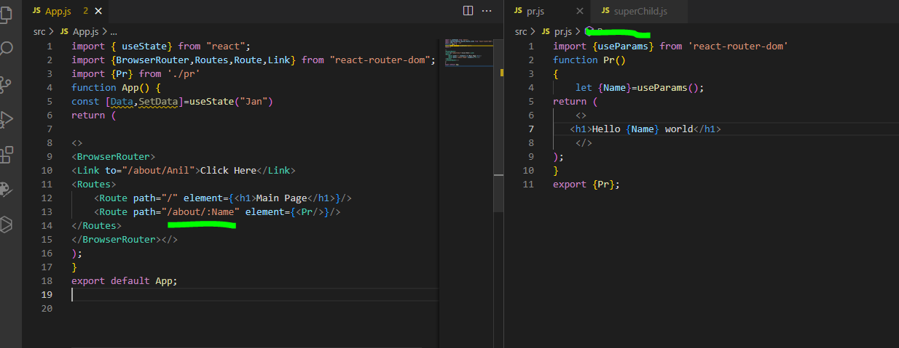

Hum parameters ka through dynamic routing kr skty hain.isky liay hamain Link ma wo argument bhejna ho ga aur us file/component ma useParams() ka through wo value get krni ho gi.

**why we write this const {name}=useparams(); instead of const name=useparams(); in react while using dynamic routing**

In React, when using dynamic routing with libraries like React Router, `useParams()` is a hook that allows you to access the parameters defined in the URL. It returns an object containing all the parameters defined in the route.

The syntax `const { name } = useParams()` is known as object destructuring. It allows you to extract specific properties from an object and assign them to variables with the same names. In this case, `useParams()` returns an object with properties corresponding to the parameters defined in the URL.

Let's say you have a route defined as `/users/:name` where `:name` represents a dynamic parameter. When you access this route with a specific name, such as `/users/john`, the `useParams()` hook will return an object like `{ name: 'john' }`. To access the value of the `name` parameter, you use object destructuring to extract it from the object returned by `useParams()`.

Using `const name = useParams()` without object destructuring would assign the entire object `{ name: 'john' }` to the `name` variable, rather than just the value of the `name` parameter. By using `const { name } = useParams()`, you are extracting the value of the `name` parameter directly into a variable named `name`.

So, the purpose of writing `const { name } = useParams()` is to extract the value of a specific parameter from the object returned by `useParams()` and assign it to a variable with the same name for further use in your React component.

For example yani useparams() return krna ha ek object just like

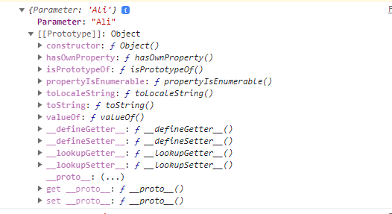

Tu is waja sa hamain const {name}=useparams() yani object destructing use krni prti ha taky parameter return ho jo url ma aya wrna useparam() pura object return kry ga.

**Link and Nav Link style**

Link ma hum ClassName nahi dety jbky hum **<NavLink> ma className da kr yani styling etc kr skty baki donon same hi hain functionality wise.Lekin anchor tag ka ye scene ha ka usmy page reload hota ha refesh jbky Link aur NavLink ma nahi hota reload application page.**

Important Link : https://www.geeksforgeeks.org/link-and-navlink-components-in-react-router-dom/

<https://www.educative.io/answers/what-are-the-differences-between-navlink-link-and-a-in-react>

**use SearchParams and setSearchParmas**

Ye react router ka hook ha react js ka nahi.

<https://www.kindacode.com/article/react-router-useparams-usesearchparams-hooks/>

# Navigation on Click | Navigating

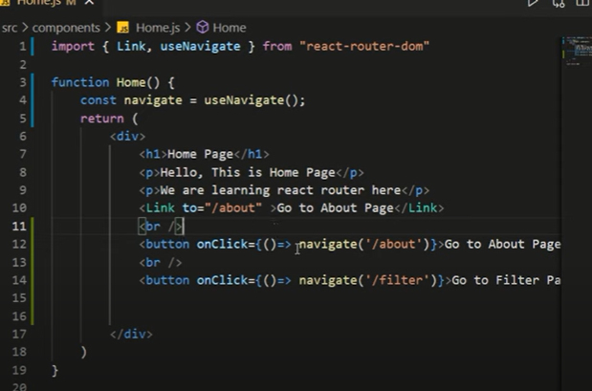

Yani agr hum button ka auper navigation krwana chahty hain instead of links tu hum useNavigate() hook use krain ga.Hum useNavigate() ko conditional routing ka liay use kr skty hain. Ya hum aisy use kr skty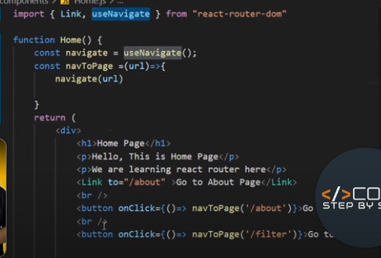

The **useNavigate()** hook is useful when you want to navigate programmatically based on certain events or conditions within your components, such as form submissions, button clicks, or other user interactions.

It's worth noting that the **useNavigate()** hook is available in React Router version 6 and above. If you are using an earlier version of React Router, you may need to use a different approach, such as the **useHistory()** hook or the **history** object provided by the **react-router-dom** package

# Nested Routing

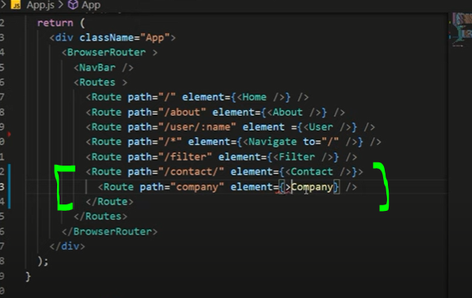

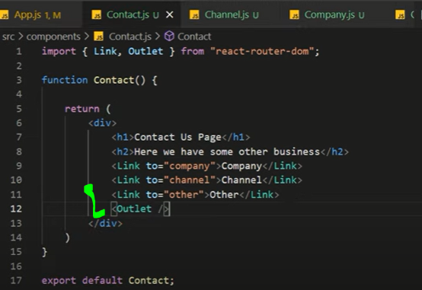

Nested routing ka liay zarori ha outlet ka tag hona component ka andr.

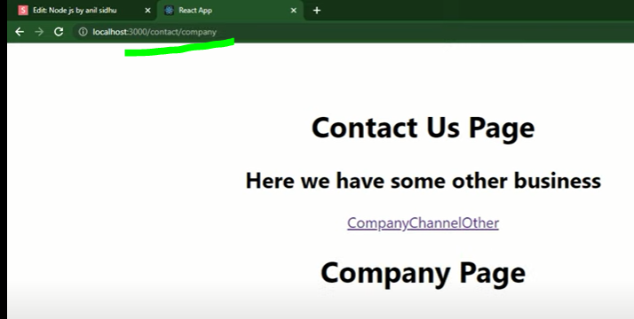

**useLocation Hooks**

The useLocation hook is a function that returns the location object that contains information about the current URL. Whenever the URL changes, a new location object will be returned.

<https://www.educative.io/answers/how-to-use-the-uselocation-hook-in-react>

jb hum ek route sa dusry route pr jaty hain aur dekhna chahty ka hamain kia mila ha yani ek route sa dusry route pr kia state ya props ya queries etc gai hain wo sb ham useLocation() hook sa mil jata hain jbky useParams() sa sirf parameter milain ga isi trha useSearchparam() etc pr wo particular ek specific cheze ka liay hain pr useLocation() hook ma ye sb chezain cover ho jati hain.Jb hum ek route sa dusry route pr jaty hain tu ek unique key generate hoti ha hamain wo ke bhi s useLocation() hook ka through mil jati ha(yani access kr skty hain is hook ka through).Hum state bhi bhej skty hain kisi route pr msln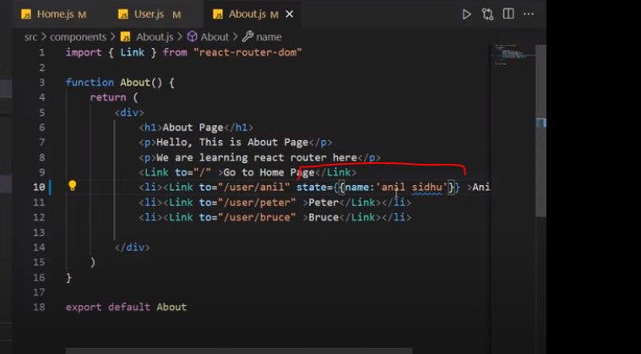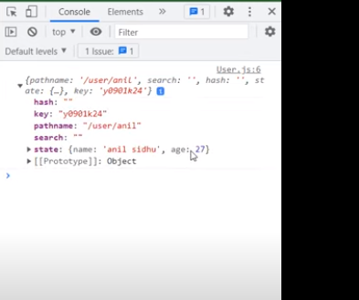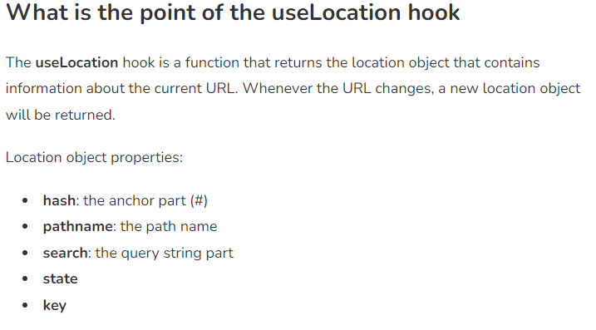

# Protected Route

**Apis**

<https://blog.logrocket.com/modern-api-data-fetching-methods-react/>

**Fetch api**

import { useState, useEffect } from "react";

function App() {

const [Data, SetData] = useState([]);

useEffect(() => {

fetch("https://jsonplaceholder.typicode.com/posts")

.then((element) => element.json())

.then((data) => {

SetData(data);

})

.catch((e) => {

console.log("Error fetch");

});

});

return (

<>

{Data.map((e) => (

<h1>{e.title}</h1>

))}

</>

);

}

export default App;

# Previous state in functional component

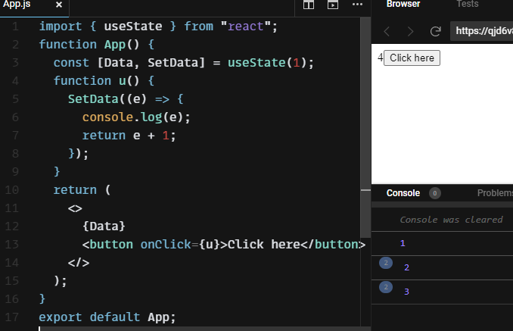

**Objects with State**

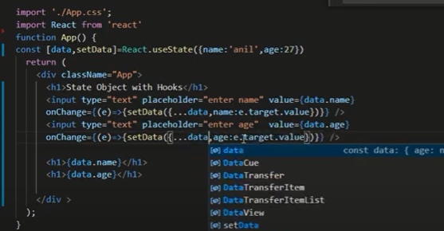

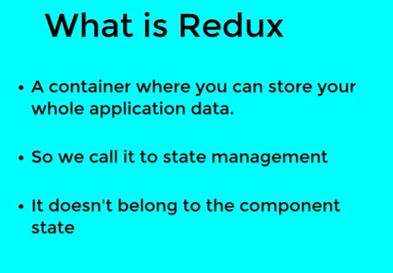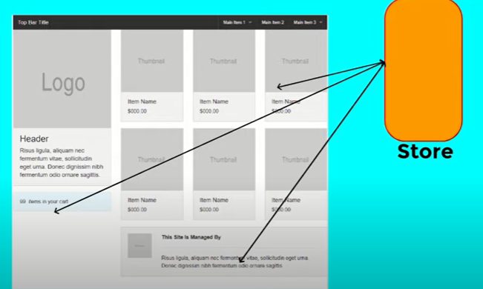

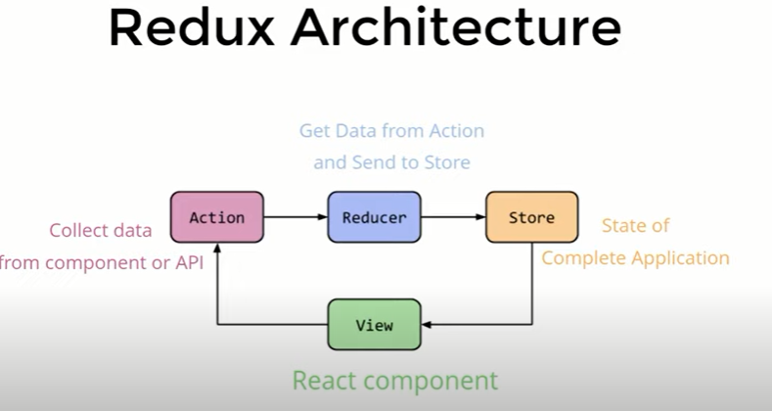

Data flows in one direction means data action sa direct store ma ya view sa reducer ma nahi ja skta.Jo flow data ka defined uni directional ha wohi rahy ga.

Installation

>npm install redux

>npm install react-redux

Redux hamari change state ko predictable banata ha.Yani hum jb apni states ko locally manage kr rahy hoty hain hamain nahi pta chalta ka state kis component ma ja kar change hoi lekin redux helps you write applications that behave consistently.

Store is a collection of states.States are imutable.Hum states ko directly change nahi krty.

->UI are bounded to state.

->Actions tell store a change is needed.

->Reducers are JavaScript pure functions.

->Each reducer manages independent state in complete store. All the reducer functions are called when action is dispatched. Reducer are the new structure of state.

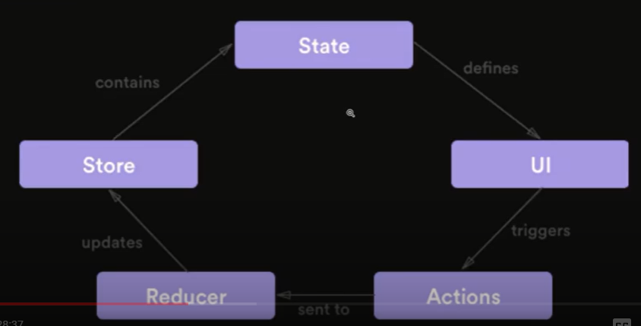

[React Redux](https://github.com/reduxjs/react-redux) is the official [React](https://reactjs.org/) UI bindings layer for [Redux](https://redux.js.org/). It lets your React components read data from a Redux store, and dispatch actions to the store to update state.

**React Redux is the official Redux UI binding library for React**. If you are using Redux and React together, you should also use React Redux to bind these two libraries.

Redux is used for efficient state management. 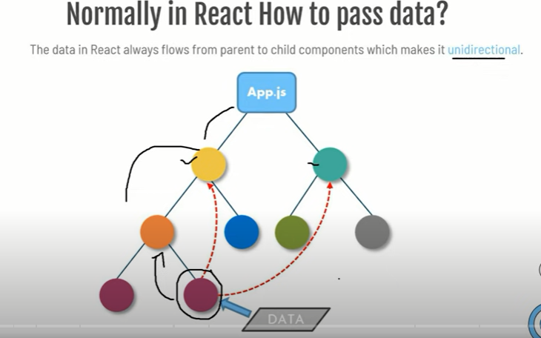

Figure Data ek flow ma move krtta ha yani top sa bottom ki trf.Bottom sa hum data top ki trf move nahi kr skty by default.Albata kuch methods hain like jaisy prop drilling

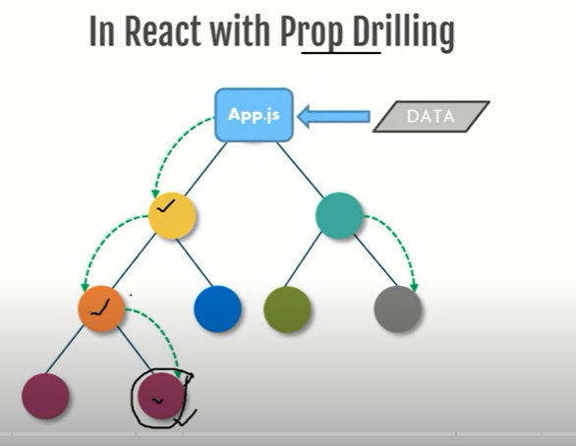

Hum as argument bhejty hain parent sa bottom side pr.Aur wo state msln parent aur targeted component ka darmian rasty ma any waly tamam components ma sa pass ho ga.

**2nd Method**

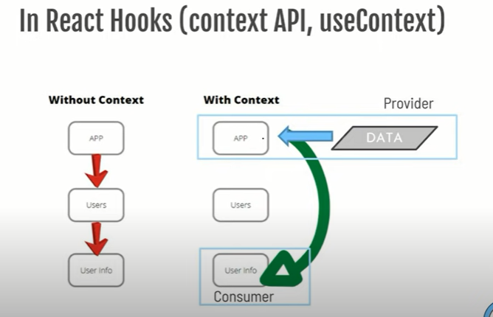

**3rd Method**

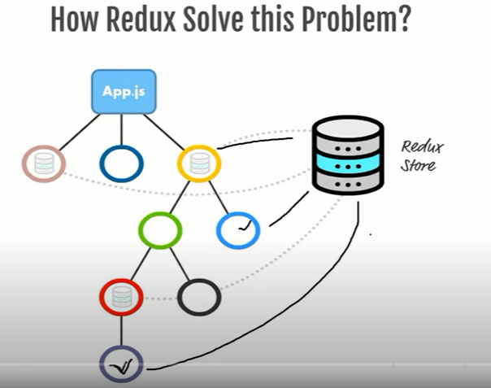

Redux ma hamary pas ek centralized store hota ha aur jis bhi component ko data chahiay ho wo us centralized Store ma sa data la leta ha. 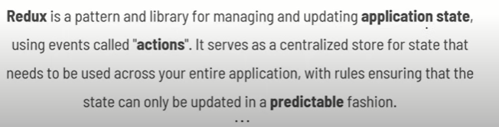 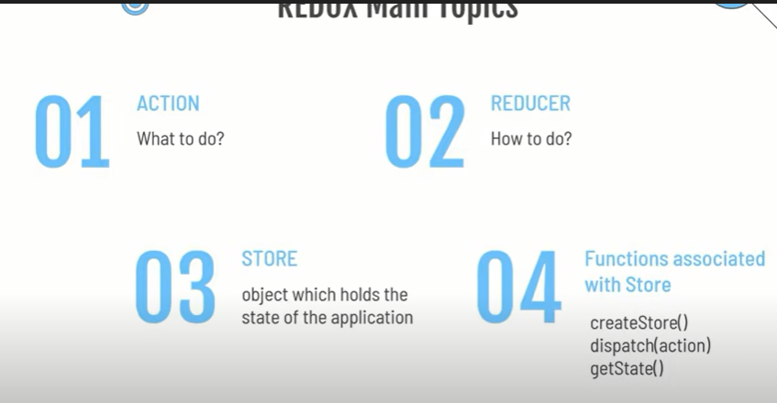

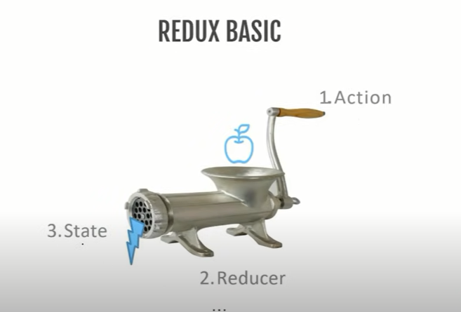

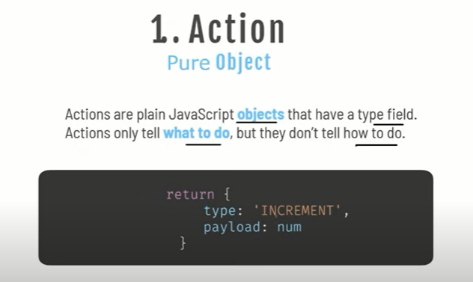

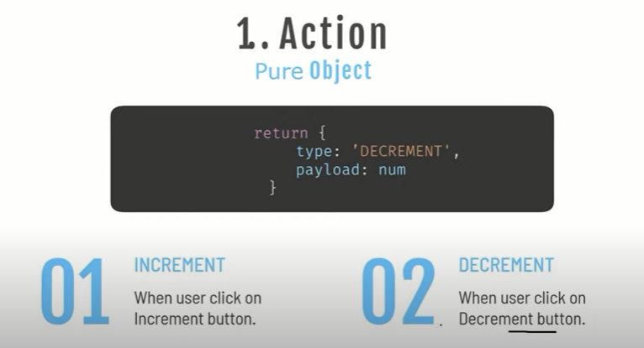

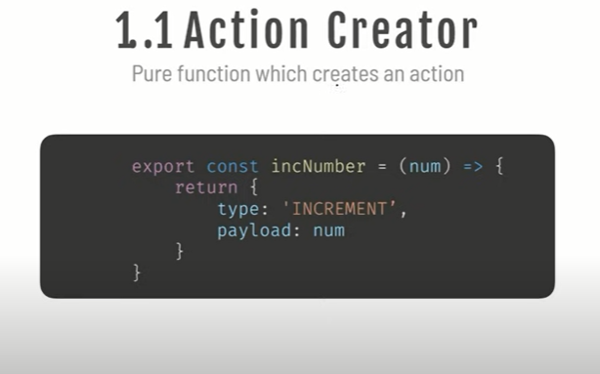

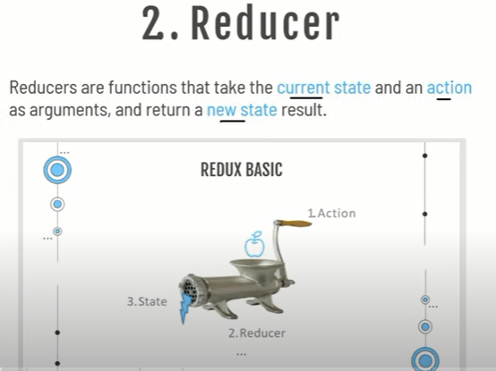

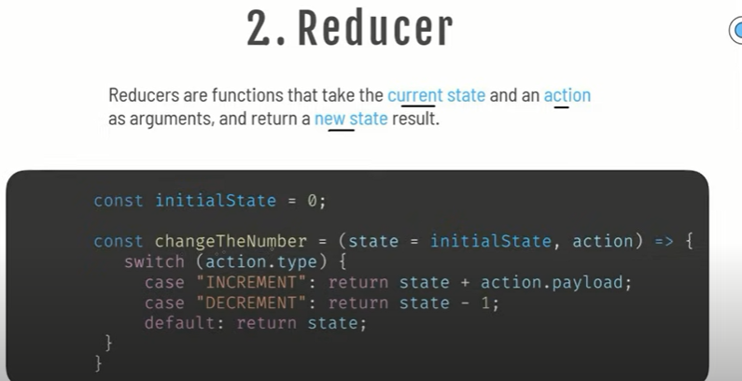 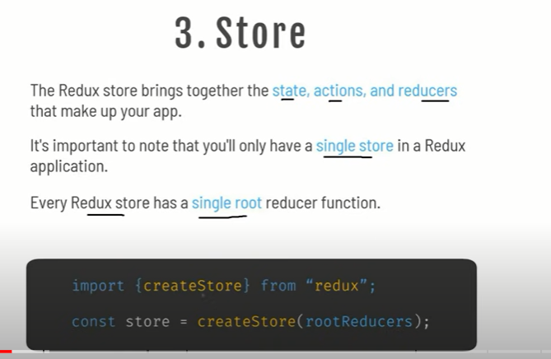

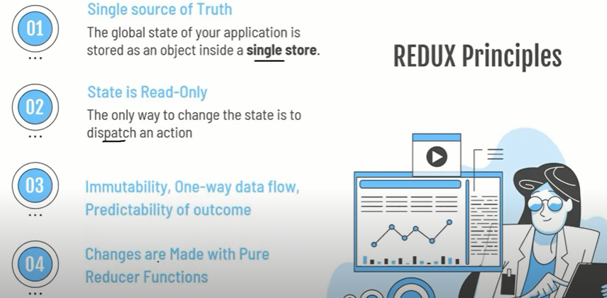

Important Note:Dispatch action ko trigger krta ha.

**framer-motion** 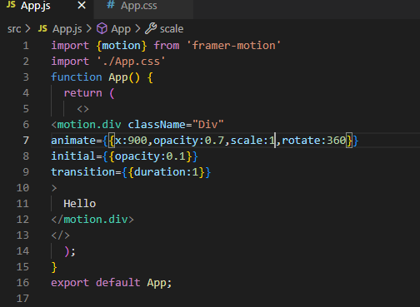

Framer-motion library use hoti ha chezon ko animate krny ka liay.Hum motion object use krty hain.Hum kisi bhi cheze pr ye apply kr skty hain msln motion.img ya motion.a ya motion.div etc.Kisi bhi cheze ko animate krny ka liay hum animate key use krty hain jismy direction deny ka liay x ya y dety hain msln hum chahty hain ka horizontal direction ma move kry tu x aur opacity yani dark ya light.Animate hony sa pehly starting initial uski kia settings hon wo configure set krny ka liay hum initial ka key ki values ma da skty hain.Animation ki speed kia ho gi wo set krny ka liay hum transition use krty hain jismy duration ma seconds dety hain.

Size change krny ka liay scale.Rotation ka liay rotate.

**Events and Drag**

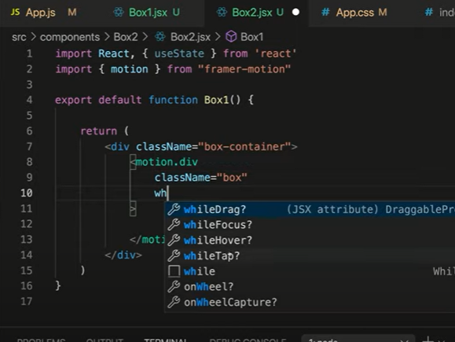

Hum animation is sense ma bhi laga skty ka element pr click ho ya uspr hover ho ya focus etc tb kia ho?Msln

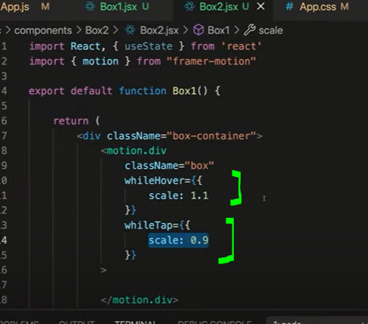

Yani jb hm is div element pr click krain gat tu size chota ho gay ani 0.9 aur jb is element pr hover krain gat u size ziada ho jay ga 1.1

**Drag Element**

Agr hum chahty hain ka ye element screen ma kahien pr bhi use drag kr sky tu humain just drag ka use krna ha msln

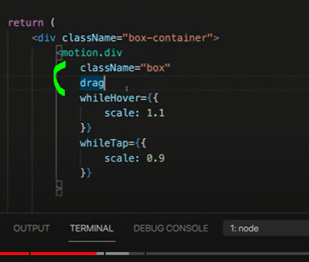

Agr hum restrict krna chahty han msln ka sirf x ya y direction ma drag kia ja sky tu hu axis da dety hain.

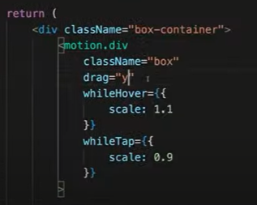

Hum constraints bhi da skty hain ka kitna move kr skta ha aur kitna nahi

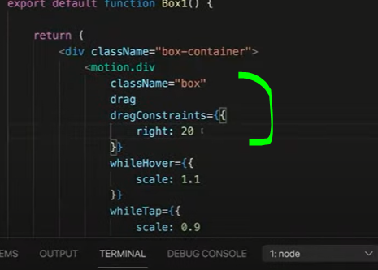

**Framer Motion variants**

Variants just grouping k liay use hota ha.

**Framer Motion Keyframes**

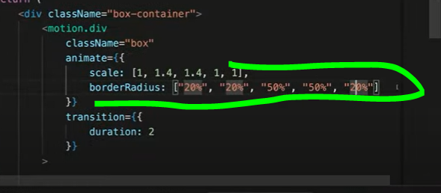

Yani hum sequence da skty ka during animation msln border size pehly 20 phr 20 phr 50 ho phr 50 aur rukny pr last a 20 ho. 

**Important Point**

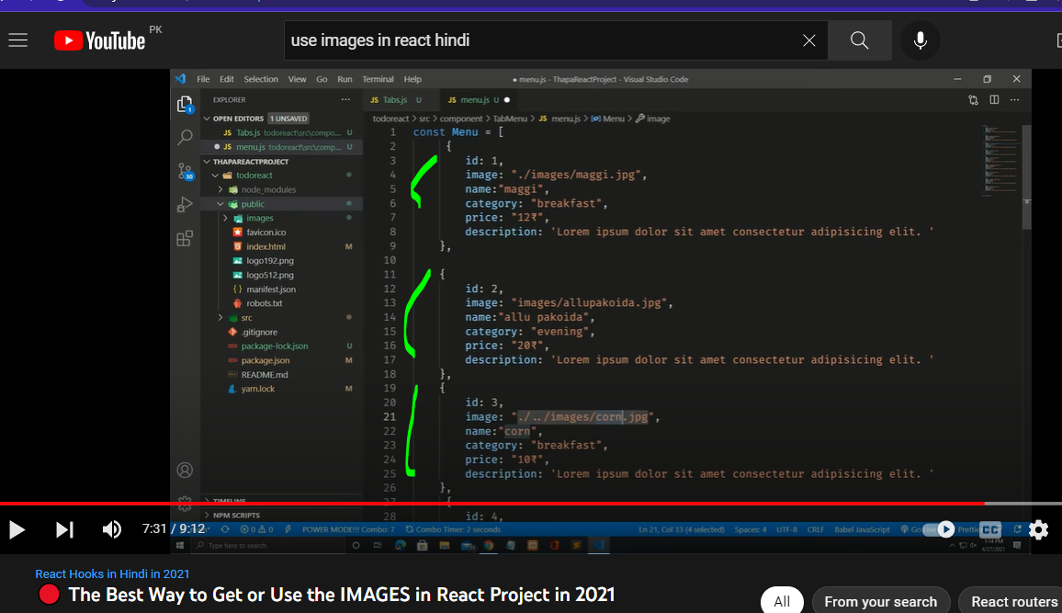

Hamesha images folder public folder ma dalty hain aur mage src dety wqt sirf folder ka nam thek dena ha baki start ma address src kisi bhi format ma ho chl jay ga.

**React Router Dom**

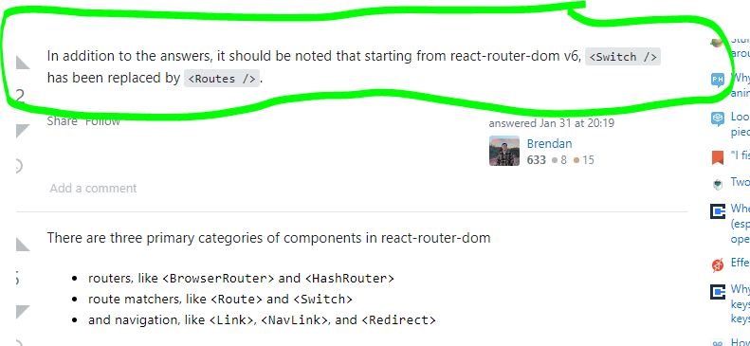 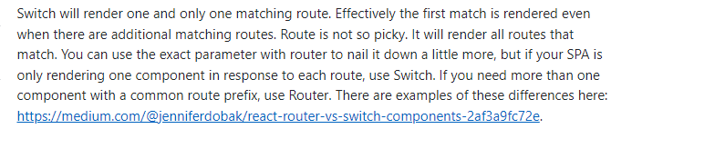

**Can we use Alone Route?**

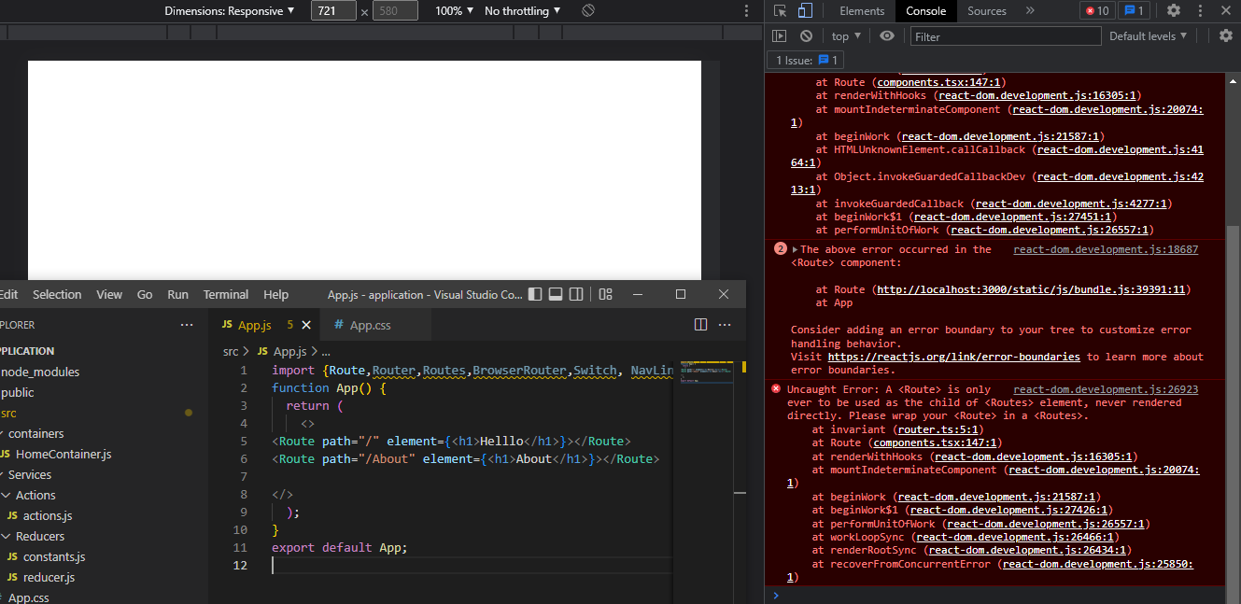

No we cant use Route alone because it must be wrapped 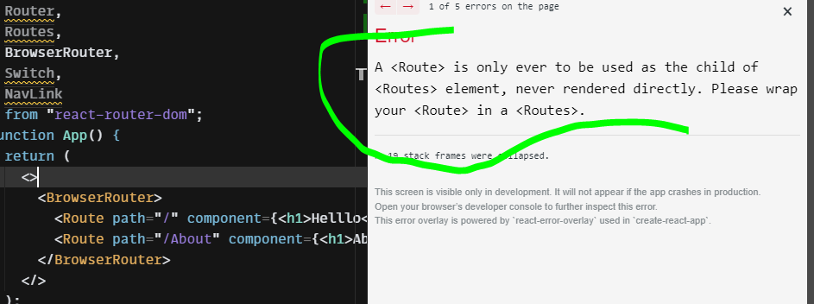

**Switch?** Agr hum switch use nahi krty thy tu jitny bhi routes hoty thy sbka components render ho jaty thy is liay hum switch use krty hain ka only 1st matching route ka component render ho bs.Msln

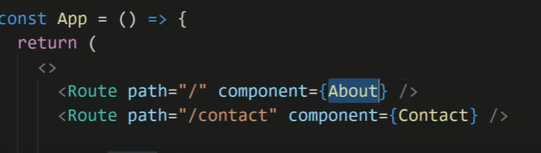

Tu dekha jay ga ka sbmy / a raha ha is waja sa / waly sary jitny bhi hain wo render ho jaien ga is liay isay baxhny ka liay agr hum chahty hain ka only wohi wala sirf component load ho tu hum switch use krty hain ya jaisy exact use krty hain.Pehly hum switch use krty thy lekin hum react router6 version ma hum <Routes> use krty hain

**BrowserRouter** hum is liay use krty hain taky hum apni application ko browser url ka sath connect kr sakain.

Purany version ma hum <Route> ka andr component likhty thy like

<Route path=”/” component={About}/>

Lekin ab hum component ki bajay element likhty hain in react router 6 version msln

<Route path=”/” element={About}/> 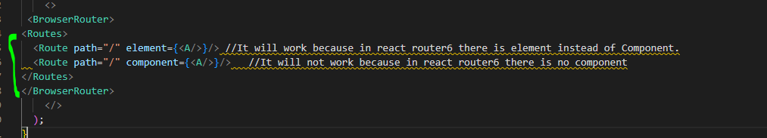

Important Point2

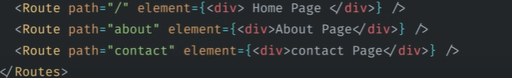

Agr hum slash/ na bhi dain tu ek hi bat ha kionky be default backslash/ automatically lag jata ha

**Nested Routing**

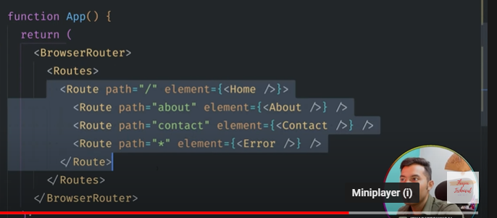

**useNavigate vs Link?**

useNavigate is router hook. Same as Link but it can navigate between route programatically, like onSubmit, it will redirect to another page. useNavigate is a hook which returns a function to navigate.But to do this we need to call a navigate function and it declares that how it will work.For example useNavigate hum aisy use kr skty hain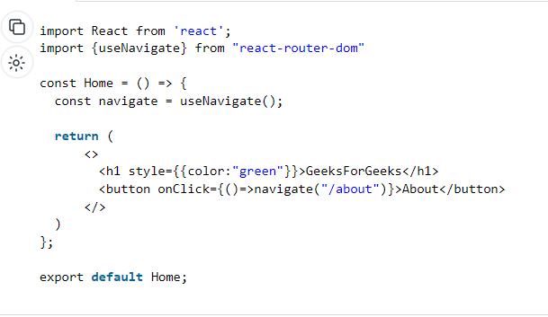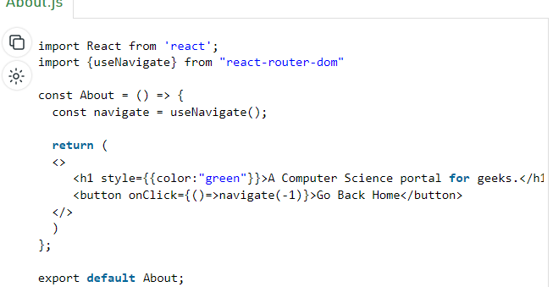

**Link s NavLink?**

Link and NavLink are mostly same thing.We use both of them to route pages.But the difference is when we use NavLink we get some advantages like we can design our navigation with active state.Because the NavLink component provides a active class inside it.So we can design our navigation when it is active and we can keep track the active pages.Hum NavLink ma className dety hain au Link ma mostly nahi ,ziada NavLink use hota ha ismy hamain active class bhi by default milti ha yani jisbhi link pr click krain us NavLink pr automatically ek new active ka nam sa class lag ay gi.